Flame Test

http://upload.wikimedia.org/wikipedia/en/8/8a/Electromagnetic-Spectrum.png
http://imagine.gsfc.nasa.gov/docs/teachers/lessons/supernova/supernova_student.html
http://www.pbs.org/newshour/extra/teachers/lessonplans/science/hubble.html
http://en.wikipedia.org/wiki/Introduction_to_quantum_mechanics

Spectroscopy
Quantum mechanics (QM, or quantum theory) is a physical science dealing with the behaviour of matter and energy on the scale of atoms and subatomic particles / waves. QM also forms the basis for the contemporary understanding of how very large objects such as stars and galaxies, and cosmological events such as the Big Bang, can be analyzed and explained. Quantum mechanics is the foundation of several related disciplines including nanotechnology, condensed matter physics, quantum chemistry, structural biology, particle physics, and electronics.

The term "quantum mechanics" was first coined by Max Born in 1924. The acceptance by the general physics community of quantum mechanics is due to its accurate prediction of the physical behaviour of systems, including systems where Newtonian mechanics fails. Even general relativity is limited—in ways quantum mechanics is not—for describing systems at the atomic scale or smaller, at very low or very high energies, or at the lowest temperatures. Through a century of experimentation and applied science, quantum mechanical theory has proven to be very successful and practical.

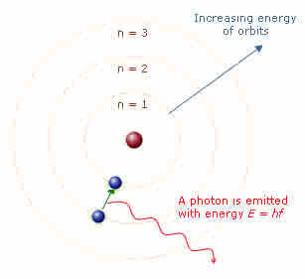
Another development was the discovery of the Zeeman effect, named after Pieter Zeeman (1865-1943). The Zeeman effect could be interpreted to mean that light waves are originated by electrons vibrating in their orbits, but classical physics could not explain why electrons should not fall out of their orbits and into the nucleus of their atoms, nor could classical physics explain why their orbits would be such as to produce the series of frequencies derived by Balmer’s formula and displayed in the line spectra. Why did the electrons not produce a continuous spectrum?

In 1897 the particle called the electron was discovered. By means of the gold foil experiment physicists discovered that matter is, volume for volume, largely space. Once that was clear, it was hypothesized that negative charge entities called electrons surround positively charged nuclei. So at first, all scientists believed that the atom must be like a miniature solar system. But that simple analogy predicted that electrons would, within about one hundredth of a microsecond, crash into the nucleus of the atom. The great question of the early 20th century was, "Why do electrons normally maintain a stable orbit around the nucleus?"
Niels Bohr Model of Discrete Quanta
In 1913, Niels Bohr removed this substantial problem by applying the idea of discrete (non-continuous) quanta to the orbits of electrons. This account became known as the Bohr model of the atom. Bohr basically theorized that electrons can only inhabit certain orbits around the atom. These orbits could be derived by looking at the spectral lines produced by atoms.

Atomic spectroscopy is an extremely important tool for scientists. Because the electron patterns around every kind of atom are unique, and because these electrons interact with light in different ways because of their different positions, you can determine what kinds of atoms are present in a substance by the kind of light absorbed or emitted by the substance. Every atom has a kind of "fingerprint" in the normal light spectrum that is measured with a device called a Spectrometer. This instrument uses a diffraction grating as a prism, splitting the incoming light into its composite colors.

As an example, a marine ecologist may suspect that the reason many bottom-dwelling organisms are dying in a local harbor is because of a chemical pollutant. She samples the mud and chemically extracts a type of metal ion, but she’s not sure what kind of metal it is. She injects the metal ions into the hot flame of an atomic emission spectrometer and observes two line spectra. The lines correspond to the wavelengths of 563 nanometers (nm) and 615 nm. This combination is the "fingerprint" for tin. The ecologist may then trace the tin to a particular type of ship's paint or a nearby industrial source.

Spectroscopy is vital for astronomers. They can analyze elements in stars and nebulae. Star fuel begins as primarily hydrogen atoms. Under extreme pressure and temperature, these atoms undergo nuclear fusion, forming helium atoms, releasing energy in the form of light. As the star ages, its fuel changes, to include the heavier elements. Helium will be used as a fuel source, fusing into heavier elements, and those into heavier elements. Iron is the heaviest element that can form in stars. Elements heavier than iron are formed in supernovae. What elements are part of the star fuel can be determined by spectroscopy.

In the first part of this lab, students will observe various light sources including tubes that have been filled with various types of gases. As electricity passes through these tubes, the gas glows and light is given off. They will compare the spectra of these gas tubes with incandescent (regular light bulb) sources or fluorescent light fixtures.

In the second part of this lab, students will conduct a flame test of 6 different known salts and one unknown chemical. Based on the flame test analysis, they will be able to identify the unknown chemical both by their spectral signature and the color of the flame.

Depending on the interest level of your students, you can discuss
- quantum mechanics
- uses of spectrometers in different areas of science from astronomy to molecular analysis
- analytical chemistry of determining the properties of an unknown chemical and comparing them to known chemicals

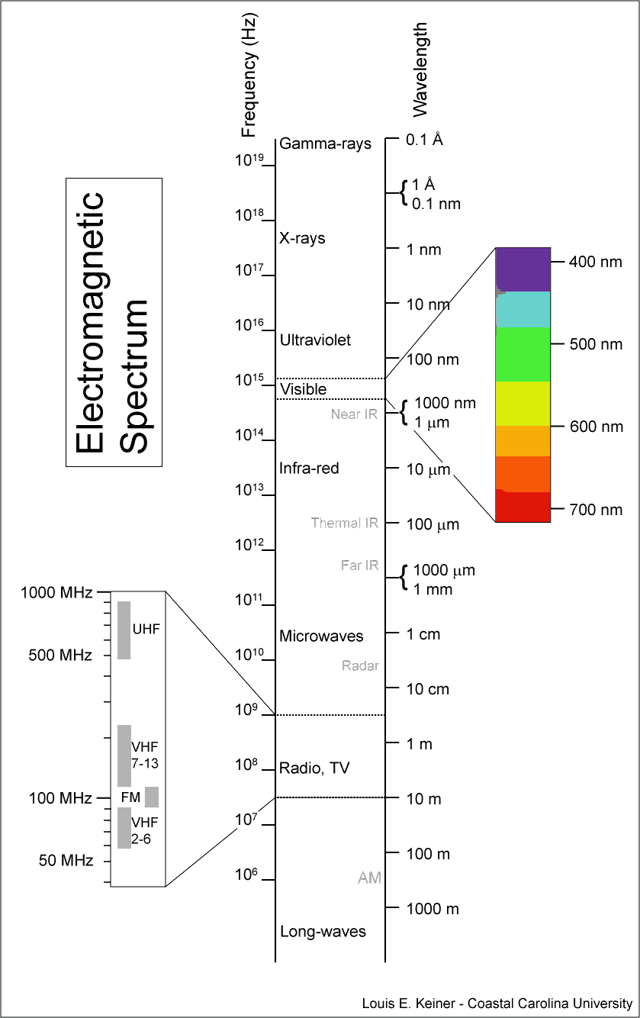
Materials:

- Spectroscopes
- Power Source
- Spectrum emission tubes
- Poster of Electromagnetic Spectrum
- Color pencils
- Alcohol burners
- Probes
- Goggles
- Denatured alcohol
- Matches
- Flame Test Chemicals in (in containers)
  - Sodium Chloride
  - Potassium Chloride
  - Lithium Chloride
  - Strontium Chloride
  - Barium Chloride
  - Calcium Chloride
  - Hydrochloric acid (HCl)
- Student worksheet
- Rubberbands

Procedure

Before the students enter the class –
- Set out goggles, the flame test chemicals, probes, alcohol burners, color pencils, student worksheet, and spectroscopes.
- Wipe the alcohol burners with a wet paper towel (in case of a fuel leak while transporting).
- Plug power source into outlet where all students can easily view it. Set out the spectrum tubes.

Class – Introduction
- quantum mechanics
- uses of spectrometers in different areas of science from astronomy to molecular analysis
- analytical chemistry of determining the properties of an unknown chemical and comparing them to known chemicals

Class – The experiment
- Instruct the students to find an unobstructed view of the power source.
- Have the students view the light (either incandescent or florescent) and replicate the spectrum with the color pencils on the student worksheet
- Switch off the lights and turn on the power source with one of the spectrum tubes inserted in the power source. Have the students record the color they see without the spectroscope.
- Instruct the students to use the spectroscopes and view the spectral lines. Have the students replicate those lines with their color pencils on the student worksheet.
- Repeat with the other spectrum tubes. Be sure to turn off the power source before removing the first tube and inserting the second tube.
- Instruct the students that they will now conduct the flame test with a partner. Each student will be responsible for testing the chemical in the flame so their partner can view the results with the spectroscope. The partners switch roles. The test may need to be conducted several times before the partners agree on the colors, both the color without the spectroscope and the spectral lines.
- Cover all safety with the students. If any student has hair long enough to put in a ponytail, they need to do so. Hand out rubber bands to those students.
- Put on goggles.
- Strike match and light the alcohol burners (either you light them, or if middle school, they can light the alcohol burners).
- The hottest part of the flame is where the flame is white then blue then yellow then orange then red is the coolest. Put probe in the hottest part of flame for better results and do not touch the wick with your probe.
- Students conduct experiment with the 7 chemicals and record the spectral lines using the color pencils and the color observed without the spectroscope.
- When you and your partner agree on your results for all 7 chemicals, extinguish alcohol burner flame with the thimble.

Discussion
- What is the color and spectral lines for each of the 7 chemicals? What is the identity of the unknown chemical?
- Helium was discovered in the Sun's corona during the eclipse of 1868. In 1888, traces of helium were isolated here on Earth. How could scientists determine that this was the same gas that had been identified on the Sun?
- Compare the results of the various gas tube spectra with the spectrum observed using the standard fluorescent light tube. Based on your results, what gas do you think is used in fluorescent light tubes?
- Was there any difference between the spectra of the standard fluorescent light tube and the compact fluorescent light fixture? Why do you think this is so?
- Compare the results of the incandescent light bulb with the spectra of the fluorescent light tube and the compact fluorescent light fixture. Based on the observed spectra, can you think of a reason why the fluorescent lights are considered as more "energy efficient"? Could there be a disadvantage to this?
- Now that you know more about what gases are contained in fluorescent lights, why do you think there is a concern about the breakage and improper disposal of these tubes?
- What colors dominated the spectrum of the "Plant Grow" light? How was this different from the regular light bulb? Can you think of a reason why this light might be better for plants (hint: plants are usually green...)?
- Explain how the bands of light are produced in the emission spectra.
- Explain how you were able to identify the unknown element contained in the discharge tube.
- Why would astronomers need to know how to identify elements?

Student Work Sheet – Identifying Emission Spectra
- With color pencils to sketch the emission spectra of elements, light, and chemicals. Identify the element, light or chemical on the line provided next to “emission spectrum.”

violet red
Light (florescent or incandescent)
_____________________ emission spectrum _____________________ color
violet red

_____________________ emission spectrum _____________________ color
violet red

_____________________ emission spectrum _____________________ color
violet red

_____________________ emission spectrum _____________________ color
violet red
potassium chloride
_____________________ emission spectrum _____________________ color
violet red
calcium chloride
_____________________ emission spectrum _____________________ color
violet red
calcium chloride
_____________________ emission spectrum _____________________ color
violet red
barium chloride
_____________________ emission spectrum _____________________ color
violet red
lithium chloride
_____________________ emission spectrum _____________________ color
violet red
strontium chloride
_____________________ emission spectrum _____________________ color
violet red

sodium chloride
_____________________ emission spectrum _____________________ color
violet red

unknown chemical
_____________________ emission spectrum _____________________ color

What is the identity of the unknown chemical?

Flame Test

Materials:

Permanent
- Spectroscopes
- Power Source
- Spectrum emission tubes
- Poster of Electromagnetic Spectrum
- Alcohol burners
- Probes
- Goggles

Consumables
- Flame Test Chemicals in (in containers)
  - Sodium Chloride
  - Potassium Chloride
  - Lithium Chloride
  - Strontium Chloride
  - Barium Chloride
  - Calcium Chloride
  - Hydrochloric acid (HCl)
- Denatured alcohol
- Matches
- Student worksheet
- Rubberbands
- Color pencils

