Carbon Dioxide vs. Water
Properties of Chemicals

http://en.wikipedia.org/wiki/Atmospheric_pressure
http://en.wikipedia.org/wiki/Water
http://en.wikipedia.org/wiki/Carbon_dioxide

Background

Carbon Dioxide
O=C=O
Dry ice is frozen carbon dioxide, a normal part of our earth's atmosphere. It is the gas that we exhale during respiration, and the gas that plants uptake in photosynthesis. It comprises about 0.038% of the total gases in the air. The other gases in our atmosphere are 78% nitrogen, 20.95% oxygen, 0.93% argon, and the balance composed of trace gases including water vapor.

Carbon dioxide is used in a wide variety of products, for example, it is gas added to soda pop to make it fizz. Dry ice is particularly useful for freezing, and keeping things frozen because of its very cold temperature, -78.5°C (-109.3°F). It is widely used because it is simple to freeze and easy to handle using insulated gloves. Dry ice changes directly from a solid to a gas -sublimating - in normal atmospheric conditions without going through a wet liquid stage.

The first step in making dry ice is to compress carbon dioxide gas until it liquefies, at the same time removing the excess heat. The C0₂ gas will liquefy at a pressure of approximately 870 pounds per square inch at room temperature. The pressure is reduced over the liquid carbon dioxide by sending it through an expansion valve into an empty chamber. The liquid will flash, with some turning into gas causing the remainder to cool. As the temperature drops to -78.5°C, the temperature of frozen CO₂, some of it will freeze into snow. This dry ice snow is then compressed together under a large press to form blocks or extruded into various sized pellets. Dry ice is much heavier than traditional ice, weighing about double.

Atmospheric pressure is the pressure at any point in the Earth's atmosphere. In most circumstances atmospheric pressure is closely approximated by the hydrostatic pressure caused by the weight of air above the measurement point. Low pressure areas have less atmospheric mass above their location, whereas high pressure areas have more atmospheric mass above their location. Similarly, as elevation increases there is less overlying atmospheric mass, so that pressure decreases with increasing elevation. A column of air 1 square inch in cross section, measured from sea level to the top of the atmosphere, would weigh approximately 14.7 lbf (pound-force). A 1m² (11sq ft) column of air would weigh about 100 kilonewtons (equivalent to a mass of 10.2 tons at the surface). This to compare to the 870 lbf needed to “force carbon dioxide gas into a liquid phase.

CO₂ is a greenhouse gas, which means it absorbs light at infrared wavelengths. An increase in the concentration of this gas would, some scientists believe, cause an increase in the atmosphere's average temperature. The high concentration of CO₂ in the atmosphere of the planet Venus is said to contribute to that planet's high average temperature. The ice caps on Mars are primarily dry ice!

At normal atmospheric pressure on this planet, frozen CO₂ doesn't melt into a liquid, but rather evaporates directly into its gaseous form (hence the name dry ice). This process is called sublimation. All of the experiments below rely on this property of dry ice. 1 pound of dry ice, when it "sublimes" (turns to gas) will produce 250 liters of gas at atmospheric pressure, enough to fill 125 2-liter bottles. That's a lot of gas!

Carbon dioxide gas is present on:
- Mercury – trace in the atmosphere
- Venus – 96.5% in the atmosphere
- Earth – 0.038 in the atmosphere
- Mars – 95.32% in the atmosphere
- Jupiter – trace (carbon dioxide and water present in the upper part of the atmosphere is thought to originate from comets crashing into the planet)
- Saturn - trace
- Titan - trace
- Enceladus (moon of Saturn) – 3.2% in the atmosphere
- Uranus – trace
- Neptune – trace

Dry ice is present on:
- Mars- mainly on ice sheets
- Ganymede (Jovian moon)

Water
O
H H
Water is a common chemical substance that is essential for the survival of all known forms of life. In typical usage, water refers only to its liquid form or state, but the substance also has a solid state, ice, and a gaseous state, water vapor or steam. Water covers 71% of the Earth's surface. On Earth, it is found mostly in oceans and other large water bodies, with 1.6% of water below ground in aquifers and 0.001% in the air as vapor, clouds (formed of solid and liquid water particles suspended in air), and precipitation. Saltwater oceans hold 97% of surface water, glaciers and polar ice caps 2.4%, and other land surface water such as rivers, lakes and ponds 0.6%. A very small amount of the Earth's water is contained within biological bodies and manufactured products. Other water is trapped in ice caps, glaciers, aquifers, or in lakes, sometimes providing fresh water for life on land.

Water moves continually through a cycle of evaporation or transpiration (evapotranspiration), precipitation, and runoff, usually reaching the sea. Winds carry water vapor over land at the same rate as runoff into the sea, about 36 Tt (10¹²kilograms) per year. Over land, evaporation and transpiration contribute another 71 Tt per year to the precipitation of 107 Tt per year over land. Clean, fresh drinking water is essential to human and other life. Access to safe drinking water has improved steadily over the last decades in almost every part of the world. However, some observers have estimated that by 2025 more than half of the world population will be facing water-based vulnerability, a situation that has been called a water crisis by the United Nations. Water plays an important role in the world economy, as it functions as a solvent for a wide variety of chemical substances and facilitates industrial cooling and transportation. Approximately 70 percent of freshwater is consumed by agriculture.

Water can appear in three states; it is one of the very few substances to be found naturally in all three states on earth. Water takes many different forms on Earth: water vapor and clouds in the sky; seawater and rarely icebergs in the ocean; glaciers and rivers in the mountains; and the liquid in aquifers in the ground.

Water can dissolve many different substances, giving it different tastes and odors. In fact, humans and other animals have developed senses that are, to a degree, able to evaluate the potability of water, avoiding water that is too salty or putrid. Humans also tend to prefer cold water to lukewarm; cold water is likely to contain fewer microbes. The taste advertised in spring water or mineral water derives from the minerals dissolved in it, as pure H₂O is tasteless. As such, purity in spring and mineral water refers to purity from toxins, pollutants, and microbes.

Different names are given to water's various forms:
- according to state
  - solid - ice
  - liquid - water
  - gaseous - water vapor

Water is the chemical substance with chemical formula H₂O: one molecule of water has two hydrogen atoms covalently bonded to a single oxygen atom. The major chemical and physical properties of water are:
- Water is a tasteless, odorless liquid at ambient temperature and pressure. The color of water and ice is, intrinsically, a very light blue hue, although water appears colorless in small quantities. Ice also appears colorless, and water vapor is essentially invisible as a gas.
- Water is transparent, and thus aquatic plants can live within the water because sunlight can reach them. Only strong UV light is slightly absorbed.
- Since oxygen has a higher electronegativity than hydrogen, water is a polar molecule. The oxygen has a slight negative charge while the hydrogens have a slight positive charge giving the article a strong effective dipole moment. The interactions between the different dipoles of each molecule cause a net attraction force associated with water's high amount of surface tension.
- Another very important force that causes the water molecules to stick to one another is the hydrogen bond.
- The boiling point of water (and all other liquids) is directly related to the barometric pressure. For example, on the top of Mt. Everest water boils at about 68 C (154 F), compared to 100°C (212°F) at sea level. Conversely, water deep in the ocean near geothermal vents can reach temperatures of hundreds of degrees and remain liquid.
- Water has a high surface tension caused by the weak interactions, (Van Der Waals Force) between water molecules because it is polar. The apparent elasticity caused by surface tension drives the capillary waves.
- Water also has high adhesion properties because of its polar nature.
- Capillary action refers to the tendency of water to move up a narrow tube against the force of gravity. This property is relied upon by all vascular plants, such as trees.
- Water is a very strong solvent, referred to as the universal solvent, dissolving many types of substances. Substances that will mix well and dissolve in water, e.g. salts, sugars, acids, alkalis, and some gases: especially oxygen, carbon dioxide (carbonation), are known as "hydrophilic" (water-loving) substances, while those that do not mix well with water (e.g. fats and oils), are known as "hydrophobic" (water-fearing) substances.
- All the major components in cells (proteins, DNA and polysaccharides) are also dissolved in water.
- Pure water has a low electrical conductivity, but this increases significantly upon solvation of a small amount of ionic material such as sodium chloride.
- Water has the second highest specific heat capacity of any known chemical compound, after ammonia, as well as a high heat of vaporization (40.65 kJ mol⁻¹), both of which are a result of the extensive hydrogen bonding between its molecules. These two unusual properties allow water to moderate Earth's climate by buffering large fluctuations in temperature.
- The maximum density of water is at 3.98 C (39.16 F). Water becomes even less dense upon freezing, expanding 9%. This causes an unusual phenomenon: ice floats upon water, and so water organisms can live inside a partly frozen pond because the water on the bottom has a temperature of around 4 °C (39 °F).

Much of the universe's water may be produced as a byproduct of star formation. When stars are born, their birth is accompanied by a strong outward wind of gas and dust. When this outflow of material eventually impacts the surrounding gas, the shock waves that are created compress and heat the gas. The water observed is quickly produced in this warm dense gas.

Water has been detected in interstellar clouds within our galaxy, the Milky Way. It is believed that water exists in abundance in other galaxies too, because its components, hydrogen and oxygen, are among the most abundant elements in the universe. Interstellar clouds eventually condense into solar nebulae and solar systems, such as ours.

Water vapor is present on:
- Mercury - 3.4% in the atmosphere, and large amounts of water in Mercury's exosphere (uppermost layer of the atmosphere)
- Venus - 0.002% in the atmosphere
- Earth - trace in the atmosphere (varies with climate)
- Mars - 0.03% in the atmosphere
- Jupiter - 0.0004% in the atmosphere
- Saturn - in ices only
- Enceladus (moon of Saturn) - 91% in the atmosphere
- exoplanets known as HD 189733 b and HD 209458 b.

Liquid water is present on:
- Earth - 71% of surface
- Moon - small amounts of water have been found (in 2008) in the inside of volcanic pearls brought from Moon to Earth by the Apollo 15 crew in 1971.

Strong evidence suggests that liquid water is present just under the surface of Saturn's moon Enceladus. There is probably some liquid water on Europa.

Water ice is present on:
- Earth - mainly on ice sheets
- polar ice caps on Mars
- Titan
- Europa
- Enceladus

Probability or possibility of distribution of water ice is at: lunar ice on the Moon, Ceres (dwarf planet), Tethys (moon). Ice is probably in internal structure of Uranus, Neptune, and Pluto and on comets.

The existence of liquid water, and to a lesser extent its gaseous and solid forms, on Earth is vital to the existence of life on Earth as we know it. The Earth is located in the habitable zone of the solar system; if it were slightly closer to or further from the Sun (about 5%, or about 8 million kilometres), the conditions which allow the three forms to be present simultaneously would be far less likely to exist.

Earth's mass allows gravity to hold an atmosphere. Water vapor and carbon dioxide in the atmosphere provide a greenhouse effect which helps maintain a relatively steady surface temperature. If Earth were smaller, a thinner atmosphere would cause temperature extremes preventing the accumulation of water except in polar ice caps (as on Mars).

It has been proposed that life itself may maintain the conditions that have allowed its continued existence. The surface temperature of Earth has been relatively constant through geologic time despite varying levels of incoming solar radiation (insolation), indicating that a dynamic process governs Earth's temperature via a combination of greenhouse gases and surface or atmospheric albedo. This proposal is known as the Gaia hypothesis.

The state of water also depends on a planet's gravity. If a planet is sufficiently massive, the water on it may be solid even at high temperatures, because of the high pressure caused by gravity.

There are various theories about origin of water on Earth. Water covers 71% of the Earth's surface; the oceans contain 97.2% of the Earth's water. The Antarctic ice sheet, which contains 90% of all fresh water on Earth, is visible at the bottom. Condensed atmospheric water can be seen as clouds, contributing to the Earth's albedo.

Hydrology is the study of the movement, distribution, and quality of water throughout the Earth. The study of the distribution of water is hydrography. The study of the distribution and movement of groundwater is hydrogeology, of glaciers is glaciology, of inland waters is limnology and distribution of oceans is oceanography. Ecological processes with hydrology are in focus of ecohydrology.

The collective mass of water found on, under, and over the surface of a planet is called the hydrosphere. Earth's approximate water volume (the total water supply of the world) is 1,360,000,000 km³ (326,000,000 mi³). Of this volume:
- 1,320,000,000 km³ (316,900,000 mi³ or 97.2%) is in the oceans.
- 25,000,000 km³ (6,000,000 mi³ or 1.8%) is in glaciers, ice caps and ice sheets.
- 13,000,000 km³ (3,000,000 mi³ or 0.9%) is groundwater.
- 250,000 km³ (60,000 mi³ or 0.02%) is fresh water in lakes, inland seas, and rivers.
- 13,000 km³ (3,100 mi³ or 0.001%) is atmospheric water vapor at any given time.

Liquid water is found in bodies of water, such as an ocean, sea, lake, river, stream, canal, pond, or puddle. The majority of water on Earth is sea water. Water is also present in the atmosphere in solid, liquid, and vapor states. It also exists as groundwater in aquifers.

The most important geological processes caused by water are: chemical weathering, water erosion, water sediment transport and sedimentation, mudflows, ice erosion and sedimentation by glacier.

The water cycle (known scientifically as the hydrologic cycle) refers to the continuous exchange of water within the hydrosphere, between the atmosphere, soil water, surface water, groundwater, and plants. Water moves perpetually through each of these regions in the water cycle consisting of following transfer processes:
- evaporation from oceans and other water bodies into the air and transpiration from land plants and animals into air.
- precipitation, from water vapor condensing from the air and falling to earth or ocean.
- runoff from the land usually reaching the sea.

Most water vapor over the oceans returns to the oceans, but winds carry water vapor over land at the same rate as runoff into the sea, about 36 Tt per year. Over land, evaporation and transpiration contribute another 71 Tt per year. Precipitation, at a rate of 107 Tt per year over land, has several forms: most commonly rain, snow, and hail, with some contribution from fog and dew. Condensed water in the air may also refract sunlight to produce rainbows.

Water runoff often collects over watersheds flowing into rivers. A mathematical model used to simulate river or stream flow and calculate water quality parameters is hydrological transport model. Some of water is diverted to irrigation for agriculture. Rivers and seas offer opportunity for travel and commerce. Through erosion, runoff shapes the environment creating river valleys and deltas that provide rich soil and level ground for the establishment of population centers. A flood occurs when an area of land, usually low-lying, is covered with water. It is when a river overflows its banks or flood from the sea. A drought is an extended period of months or years when a region notes a deficiency in its water supply. This occurs when a region receives consistently below average precipitation.

In section B, you collected data comparing dry ice to water ice. We are going to analyze these data. Scientists use graphs to make pictures of the data, which is a much easier way to “read” the results to answer our questions. (Note: data is a plural word, like scissors. The singular is datum.)

All of the data collected is a rate (how much per second, minute, or hour), and therefore your graph needs to display that rate. A good graph would be a scatter plot with the x axis as time and the y axis as the measure of the change.

How to build a scatter plot in Excel (The example is bogus data):

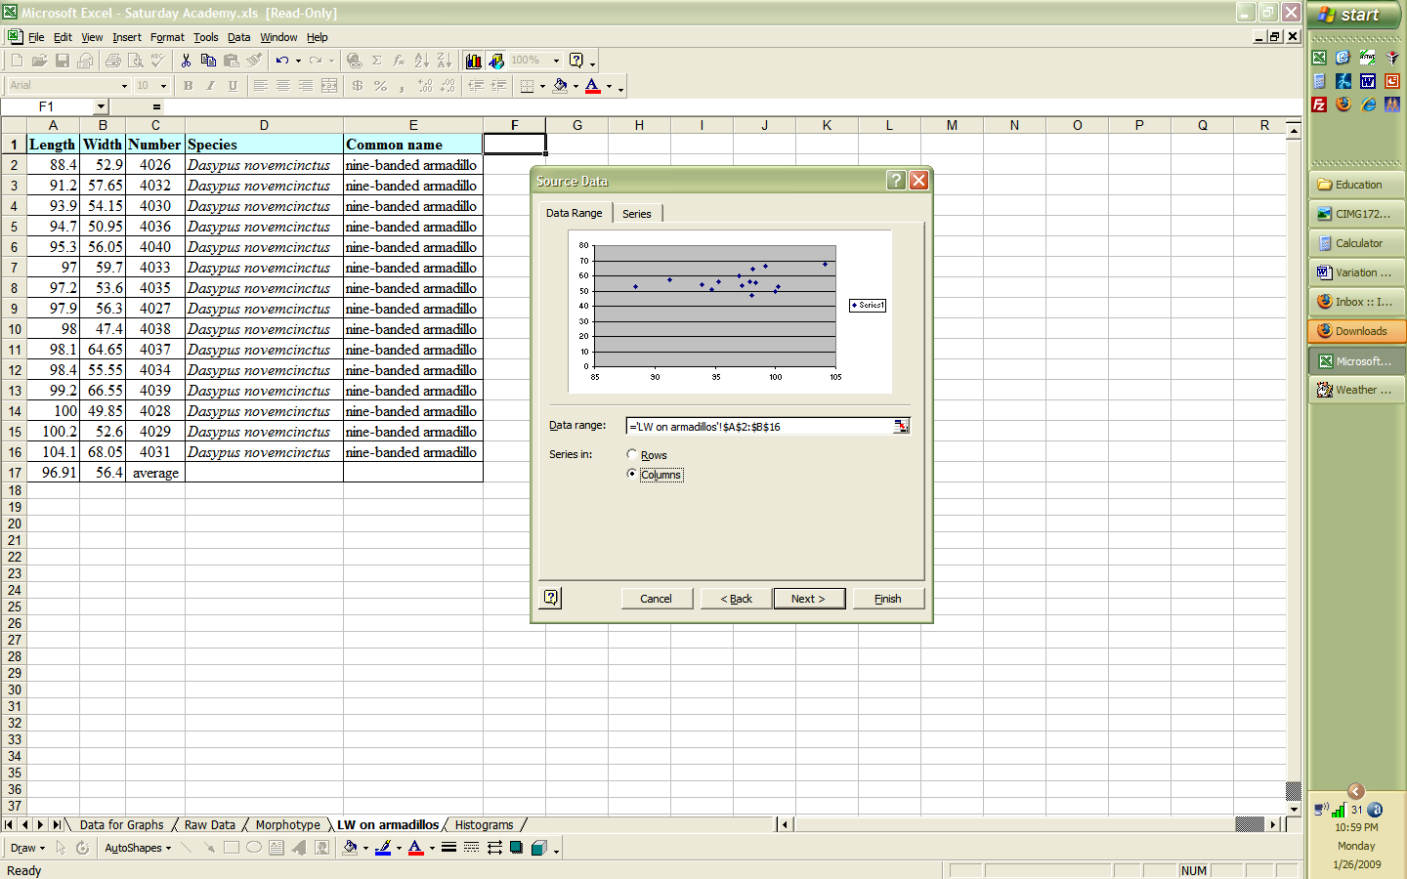
Select “Graphs” in the “Insert” menu or the icon for building graphs. Select “XY Scatter.” You want the first scatter plot, the one without the lines. On step 2 of 4, the menu will prompt you for the data range. Pick the tab “Data Range.” Click in the Data Range space, and then you can select the columns you want to include in the graph. If you have an average column (as there is in this example) do not select that. Only select the measurements.

On the next menu (page 3 of 4) you can remove the unnecessary “Series” and the legend box. Add the graph title and the axes labels.

How to build a scatter plot by hand (The example is bogus data):

http://www.terragon.com/tkobrien/algebra/topics/scatterplots/scatterplots.html

A history teacher asked her students how many hours of sleep they had the night before a test. The data below shows the number of hours the student slept and their score on the exam. The graph is a scatter plot from the given data.

Student Number  1  2  3  4  5  6  7  8  9  10 | Hours Slept  8  7  7  8  6  5  7  4  9  7 | Test Score  83  86  74  88  76  63  90  60  89  81 | 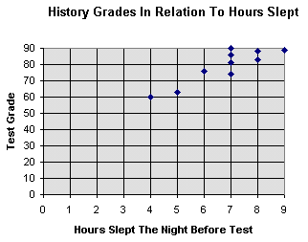

Make a Best Fit Line for the data:

To approximate a best fit line for the data in the graph above. First sketch a line that closely fits the data. Second, locate two points on the line. They don't have to be one of the original data points. We, will choose, (4,60) and (7,80) for this example.

http://www.purplemath.com/modules/slope.htm

For older students, you can find the equation of a line using:

y = mx + b

This is called the slope-intercept because “m” is the slope and “b” gives the y-intercept. e of the most important properties of a straight line is in how it angles away from the horizontal. This concept is reflected in something called the "slope" of the line.
Let's take a look at the straight line y = ( ²/₃ )x – 4. Its graph looks like this:  To find the slope, we will need two points from the line. |  | 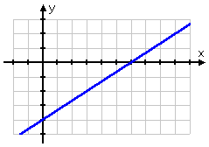
Pick two x's and solve for each corresponding y: If, say, x = 3, then y = ( ²/₃ )(3) – 4 = 2 – 4 = –2. If, say, x = 9, then y = ( ²/₃ )(9) – 4 = 6 – 4 = 2. (By the way, I picked the x-values to be multiples of three because of the fraction. It's not a rule that you have to do that, but it's a helpful technique.) So the two points (3, –2) and (9, 2) are on the line y = ( ²/₃ )x – 4.
To find the slope, you use the following formula:
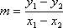
(Why "m" for "slope", rather than, say, "s"? The official answer is: Nobody knows.)
The subscripts merely indicate that you have a "first" point (whose coordinates are subscripted with a "1") and a "second" point (whose coordinates are subscripted with a "2"); that is, the subscripts indicate nothing more than the fact that you have two points to work with. It is entirely up to you which point you label as "first" and which you label as "second". For computing slopes with the slope formula, the important thing is that you subtract the x's and y's in the same order. For our two points, if we choose (3, –2) to be the "first" point, then we get the following:
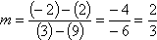
The first y-value above, the –2, was taken from the point (3, –2) ; the second y-value, the 2, came from the point (9, 2); the x-values 3 and 9 were taken from the two points in the same order. If we had taken the coordinates from the points in the opposite order, the result would have been exactly the same value:
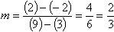
As you can see, the order in which you list the points really doesn't matter, as long as you subtract the x-values in the same order as you subtracted the y-values. Because of this, the slope formula can be written as it is above, or alternatively it can be written as:
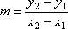Copyright ©
Let me emphasize: it does not matter which of the two formulas you use or which point you pick to be "first" and which you pick to be "second". The only thing that matters is that you subtract your x-values in the same order as you had subtracted your y-values.
Technically, the equivalence of the two slope formulas above can be proved by noting that:
y₁ – y₂ = –y₂ + y₁ = –(y₂ – y₁)
x₁ – x₂ = –x₂ + x₁ = –(x₂ – x₁)
Doing the subtraction in the so-called "wrong" order serves only to create two "minus" signs which cancel out. The upshot: Don't worry too much about which point is the "first" point, because it really doesn't matter. (And please don't send me an e-mail claiming that the order does somehow matter, or that one of the above two formulas is somehow "wrong". If you think I'm wrong, plug pairs of points into both formulas, and try to prove me wrong! And keep on plugging until you "see" that the mathematics is in fact correct.)
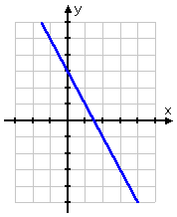
Let's find the slope of another line equation:
- Find the slope of y = –2x + 3.
Graphing the line, it looks like this:
I'll pick a couple of values for x, and find I'll find the corresponding values for y. Picking x = –1, I get y = –2(–1) + 3 = 2 + 3 = 5. Picking x = 2, I get y = –2(2) + 3 = –4 + 3 = –1. Then the points (–1, 5) and (2, –1) are on the line y = –2x + 3. The slope of the line is then calculated as:

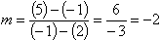

To find the actual slope of your data for a Best Fit Line:
m = (80-60) / (7-4)  m = 20 / 3  m = 20/3  y = mx + b  y = 20/3x + b  60 = (20/3)4 + b  60 = 80/3 + b  100/3 = b  Thus a best fit equation is:  y = 20/3x + 100/3 | 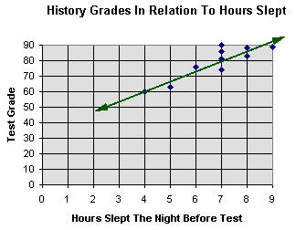
A scatter plot shows the relationship between 2 variables. We will look at three relationships between x & y: Positive, Negative and No relationship.
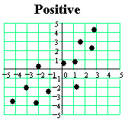
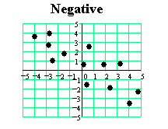
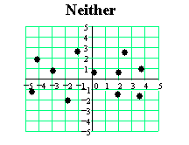

Data Conclusions

After your students have completed the data analysis, you can ask them to display their findings in a variety of methods, but the most creative is the scientific poster.

In this poster, students will need to do the following:
- Find a creative way to present the experiment.
- Have fun with this, especially the artsy students!
- Be neat and orderly.
- They need 4 sections plus a title in your poster.
  - Title – generally, what is this research? Can include something catchy. Some examples:
    - Walk on the Wild Side: How Mammals Move
    - Where Art Thou Ernanodon? Comparing skeletons of ground and tree sloths, anteaters, armadillos, and glyptodonts to Ernanodon to determine if it is related
    - Sloths et al. Teaching Scientific Inquiry to 3rd – 8th graders
  - Introduction – tell me about dry ice and water ice. You need to use experts’ ideas, but stated in your own words. Let me know what expert you learned about these two chemicals. I cite sources in lines like this (Shaw 2008) or (Shaw et al. 2008) for more than one author. Include a list of sources that you cite. This introduction should help me understand your particular experiment. Your students will need to spend time researching these two chemicals.
    - Dry ice: what kind of chemical is it? Is it found naturally in the environment, or is it manufactured? How does it impact our environment?
    - Water ice: what kind of chemical is it? Is it found naturally in the environment, or is it manufactured? How does it impact our environment?
  - Methods – what is the experimental design. In this section, you can list the materials and supplies you used, diagrams, drawings or photos of the design in action. Be sure to include everything so that someone who has never done this experiment could replicate your experiment.
    - Your hypothesis
    - All the materials (be specific, i.e.
      - Dry ice in approximately 2” cubes
    - How are these materials put together?
    - What do you do to make the compare these two chemicals?
    - How did you measure them?
  - Results
    - Put your data into a table (you can make it similar to your collection sheet)
    - Develop at least 1 graph of your data (suggestion, bar graph or scatter plots will both work)
      - You may draw your graph by hand but you MUST use a ruler and graph paper (free on the internet)
  - Discussion/Conclusions
    - What happened in your experiment?
    - Was your hypothesis supported or rejected?

Example of poster on a crater impact experiment:
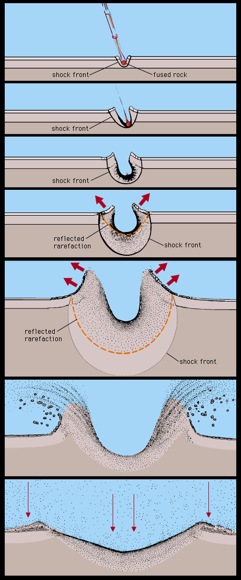
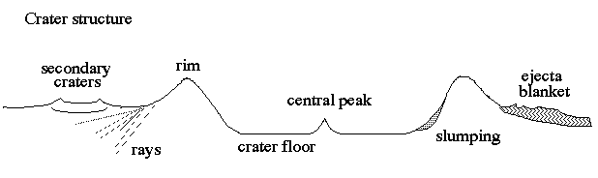
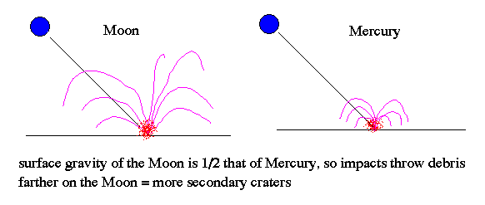
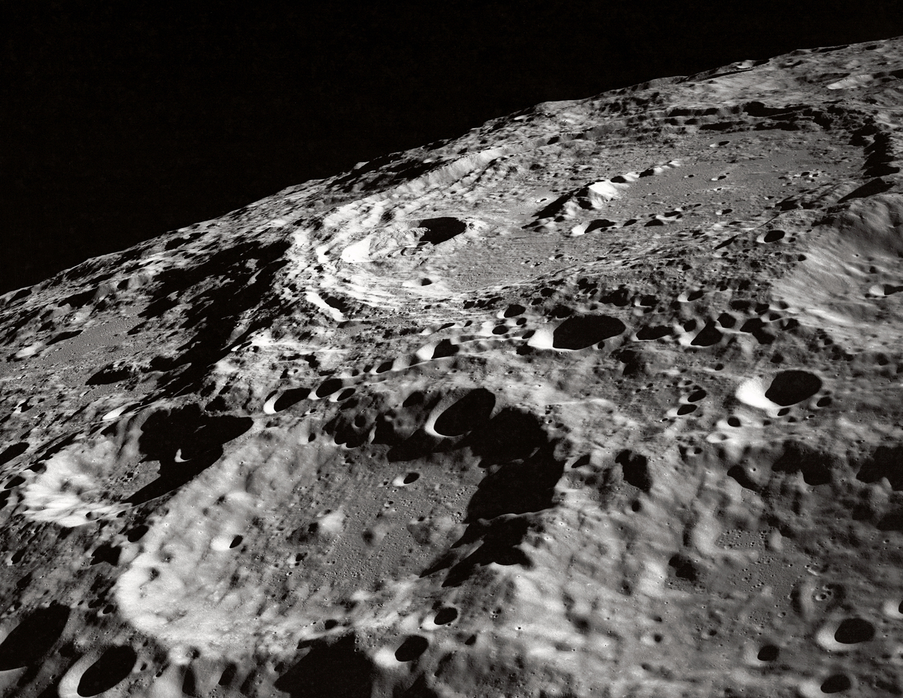
Introduction
Blah blah blah blah blah blah blah blah blah blah blah blah blah blah blah blah blah blah blah blah blah blah blah blah blah blah blah blah blah blah blah blah blah blah blah (Shoemaker 1996).
Blah blah
blah blah blah
blah blah blah
blah blah blah
blah blah blah
blah blah blah
(Levy 1996).
Methods

Clay

Pan

Flour
Results
Citations
http://spaceguard.esa.int/NScience/neo/images/crt-morph.gif
http://abyss.uoregon.edu/~js/images/impact.gif
http://abyss.uoregon.edu/~js/ast221/lectures/lec12.html
http://www.physics.unlv.edu/~jeffery/astro/moon/moonscape/nasa_moon_crater_302.jpg
Discussion
Blah blah blah blah blah blah blah blah blah blah blah blah blah blah blah blah blah blah blah blah blah blah blah blah blah blah blah blah blah blah blah blah blah blah blah.
Blah blah blah blah blah blah blah blah blah blah blah blah blah blah blah blah blah blah blah blah blah blah blah blah blah blah blah blah blah blah blah blah blah blah blah.

Hypothesis is “Rejected”
or “Supported.”
What A Blast: Crater Impact
Variables of Speed and Angle
Hypotheses:
The crater size will be larger and deeper the faster the meteor strikes.
The shape of the crater will remain circular regardless of the angle the meteor strikes.

If your students conducted different experiments for the dry ice/water ice experiment, then each team can present their results for a better holistic picture of the differences and similarities between dry ice and water ice.

As a final product, your students could write a paper (using the same sections as needed in the scientific poster) incorporating all information learned by the entire class and applying this information to chemistry, global warming, planetary science, or botany, depending on your current science topic.

Name:

Terms in phase changes

Increasing Energy

Sublimation

Plasma
Gas
Liquid
Solid
Vaporization
Melt
Ionization
Condensation
Freeze
Deionization
Deposition

Decreasing Energy

Increasing energy causes a solid to melt into a liquid, a liquid to vaporize into a gas, and a gas to deionize into plasma. Some substances do not go through a liquid phase. Under those circumstances, the solid will sublimate to a gas. Decreasing energy will deionize plasma into a gas, condense gas into a liquid, and freeze a liquid into a solid. If a gas doesn’t pass through the liquid phase, then the gas will depose to a solid.
HOLD BY RIM

Safety
***************WARNING! ***************
Dry Ice is very cold (-109 ° F).
Do NOT handle with bare hands.
Handle with extreme CAUTION!
Use dry gloves when handling.
Wear goggles.
Do NOT ingest dry ice.
Do NOT seal in glass or other tightly closed containers.
Do NOT enter poorly ventilated areas where used or stored.
Do NOT leave children or pets in a vehicle with dry ice.
Carbon Dioxide gas is not poisonous or toxic, but it will NOT support life.
If transported in a vehicle, leave at least one window open, or otherwise provide for ample fresh air ventilation.

Polar Water Molecule Non-Polar Carbon Dioxide Molecule
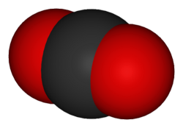
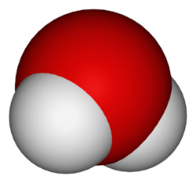
H₂O CO₂
Experiments

Set A: Comparing Chemical Properties
You will be instructed to select one of the following:
- Be assigned one of the following experiments - or –
- Read through experiments 1-4 and select one of them to complete
- Complete all 4 experiments

- Rate of sublimation/melting in air:
  - How fast will the dry ice and water ice sublimate/melt?
  - You will need 1 ice cube, 1 piece of dry ice about the same size, 1 piece of dark construction paper, and ability to see the classroom clock.
  - Find the mass of ice. Record in grams.
  - Find the mass of dry ice. If it is substantially bigger, get a smaller piece of dry ice. Record in grams.
  - Get a black piece of construction paper, and place the dry ice on one side, and the ice cube on the other side.
  - Record your initial observation about each substance.
  - After 10 minutes, record the mass of the ice and dry ice.
  - Continue recording every 10 minutes until your ices are gone.
  - Be sure to return the ices to the dark piece of paper each time you record.
  - Set up this experiment, and while running, continue on to other experiments.

- Rate of sublimation in water:
  - How fast will the dry ice and water ice sublimate/melt in water?
  - You will need 1 cube of dry ice and 1 cube of water ice –the same size and shape, 2 plastic cups, a thermometer, water, and ability to see the classroom clock.
  - Weigh and record the mass of each of the dry ice and water ice.
  - Run tap water and hold one of the thermometers in the stream of water. Adjust the water until the water is the same temperature as the air (70ºF)
  - Fill the cup with water about ¾ full
  - Put one piece of dry ice and one ice cube in each of the two cups.
  - Place the dry thermometer in each cup without the water, keeping it as far away from the dry ice as possible
  - Place the wet thermometer in the cup with the water, keeping it as far away from the dry ice as possible.
  - Record the temperature and approximate size of each piece of dry ice every minute.
  - When one of the pieces of dry ice is completely sublimated, note the time, the size of the other piece of dry ice, and end the experiment.

- Which is colder?

Which will cool water faster, the dry ice or the water ice?

You will need a piece of dry ice, an ice cube, 2 cups a thermometer, and water.

Weigh the dry ice and record the mass.

Weigh the ice and record the mass.

Fill the two cups half full with water.

Use the thermometer, and record the temperature of each cup.

Place the ice cube in one cup while your partner places the dry ice in the other.

Record your start time.

Record the temperature after 10 minutes.

Record the temperature after 20 minutes.

Record the temperature after 30 minutes.

Inflate Latex Gloves:

What is the volume difference between the carbon dioxide as a solid and the carbon dioxide as a gas? Will water show the same trends?

You will need 1 ice cube, 1 piece of dry ice about the same size, 2 latex gloves, and a tape measurer.

Open the wrist of the first glove and drop a piece of dry ice into it.

Weigh the dry ice/latex glove mass.

Open the wrist of the second glove and drop a piece of ice into it.

Weigh the ice/latex glove mass.

Tie off the two gloves at the same time and record the start time.

Measure around the middle of each glove and record that measurement.

After 10 minutes, weigh and measure each glove and record that measurement.

Continue recording every 10 minutes until your ices are gone.

Set B: Cool Stuff
After you have completed the above experiment(s), read through experiments 5-11, and select one. If you have additional time, you may continue working in this section.

Carbonic Acid or Base?

The ocean uptakes carbon dioxide as a sink, and therefore, that reduces the overall CO₂ input into the atmosphere. Does carbon dioxide, when dissolved in water, change the properties of water?

You will need a piece of dry ice, an ice cube, 2 cups and water and 2 pipettes of indicator

Fill the two cups half full with water.

Place the ice cube in one cup while your partner places the dry ice in the other.

Record your start time.

Record your observation.

At the same time, add the indicator, one to the dry ice water and one to the ice cube water.

Record your observations.

Time how long it takes for a change to occur.

Record your observations.

Observe 5 minutes later. Are there any additional changes?

Popping Film Canisters: If your canister isn’t popping, please try a different one.

Does gas take up more room than solid? Will dry ice and water ice behave similarly?

You will need 1 ice cube, 1 piece of dry ice about the same size and will fit into the film canisters, 2 film canisters (be sure that they are identical) and ability to see the clock
  - Find the mass of ice. Record in grams.
  - Find the mass of dry ice. If it is substantially bigger, get a smaller piece of dry ice. Record in grams.

Place a piece of dry ice into a plastic 35mm film container.

Place an ice cube into the second film canister.

At the same time, put the lids on the film canisters and record the time.

Record when each canister pops its tops.
- Friction:
  - Ice is very slippery. What is the difference and similarities between the two if we use dry ice and water ice as a “hockey puck?” In other words, is one better at reducing the friction on the surface?
  - You will need one piece of dry ice and one ice cube.
  - Put both on the table.
  - Using the craft sticks only, rub them back and forth on the surface of the table to make the surface smooth.
  - Using the craft sticks, bat the ice and dry ice to each other – back and forth.
  - Record your observations.
- Bubble Bubble Boil and Trouble
  - What happens if you add soap to dry ice and water ice?
  - You will need a piece of dry ice, an ice cube, 2 cups and water, and dish soap.

Fill the two cups half full with water.
  - Place the ice cube in one cup while your partner places the dry ice in the other.
  - Add a drop (one drop and only one drop) of dish soap to each cup.
  - Record your observations.
- Singing Spoon:

Do the properties of dry ice and water ice cause metal to change?

You will need a metal spoon or quarter and a piece of dry ice and an ice cube., or other piece of metal.

Press a spoon or quarter firmly against a chunk of dry ice. (Use your craft stick, and be careful that your skin on either side of the craft stick doesn’t touch the dry ice.)

Record your observations.

Press a spoon or quarter firmly against a chunk of ice.
  - Record your observations.

Lasers

How does a laser light affect dry ice and water ice?

You will need a piece of dry ice, an ice cube, 2 cups, water, and a laser.

Fill the two cups half full with water.

Place the ice cube in one cup while your partner places the dry ice in the other.

Shine the laser light through the cup below the water line, at the water line, and above the water line of the ice cube cup. Record your observations.

Shine the laser light through the cup below the water line, at the water line, and above the water line of the dry ice cup. Record your observations.

Exploding Gas

Gas is dangerous. Can the gas vapors from dry ice cause a flame to explode?

You will need a piece of dry ice, an ice cube, 2 cups, water, match, and candle.

Fill the two cups half full with water.

Place the ice cube in one cup while your partner places the dry ice in the other.

Light the candle.

Without pouring the water out of the cup, tip the ice cube cup over the candle and hold. Record your observations.

Without pouring the water out of the cup, tip the dry ice cup over the candle and hold. Record your observations.

Repeat two more times for a total of three trials.

Set C: Clean-up Stations

Complete the following:
- Spic and Span
  - Please clean up any spills, rinse all cups of soapy water, and return all supplies to their stations.
DATA SHEET

Names:

Set A: Initial Observation

Dripping Dry Ice and Water Ice: (Record your observations)

Dry Ice

Water Ice

Fog Effects: (Record your observations)

Dry Ice

Water Ice

Set B: Comparing Chemical Properties

Rate of sublimation/melting in air
Time | Mass Dry Ice | Mass Water Ice

Initial

10 min

20 min

30 min

40 min

50 min

60 min

Rate of sublimation/melting in air
Time | Mass Dry Ice | Mass Water Ice

Initial

10 min

20 min

30 min

40 min

50 min

60 min

Which is Colder?
Time | Water with Dry Ice |  | Water with Ice Cubes
Initial | Mass | Temperature | Mass | Temperature

10 min

20 min

30 min

40 min

50 min

60 min

Inflate Latex Gloves
Time | Dry Ice |  | Water Ice
Initial | Mass | Circumference | Mass | Circumference

10 min

20 min

30 min

40 min

50 min

60 min

Set C: Cool Stuff (Pick one)

Carbonic Acid or Base?
Time | Dry Ice |  | Water Ice
Initial | Mass | Color | Mass | Color

Time to change

5 min

Popping Film Canisters: (Record your observations)

Dry Ice

Water Ice

Friction: (Record your observations)

Dry Ice

Water Ice

Bubble Bubble Toil and Trouble: (Record your observations)

Dry Ice

Water Ice

Singing Quarters or Spoons: (Record your observations)

Dry Ice

Water Ice

Lasers: (Record your observations)
Light Through: | Observations of Dry Ice | Observations of Water Ice

Water in Cup

At Water Line

Above Water

Exploding Gas: (Record your observations)
Trials | Observations of Dry Ice | Observations of Water Ice

Trial 1

Trial 2

Trial 3

Set E: Clean-up Stations – Everyone

Spic and Span – all tidy???

Additional observations:

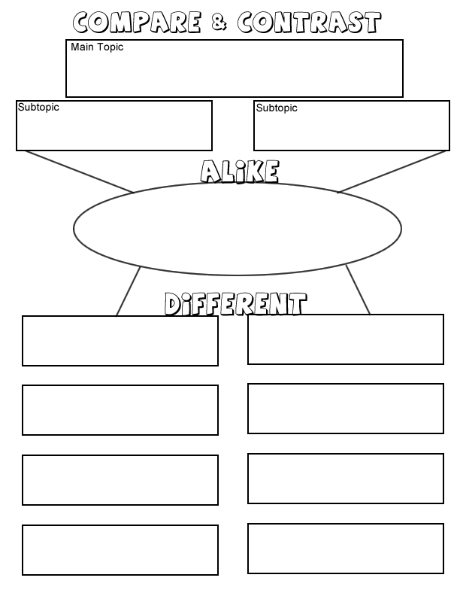
Data Analysis
Dry ice (solid Carbon Dioxide)
Water Ice (solid Dihydrogen Monoxide)
Properties of Chemicals: Dry Ice compared to Water Ice
Name

