Tree Sloths, Anteaters and Armadillos
Glyptodons, Pampatheres and Ground Sloths
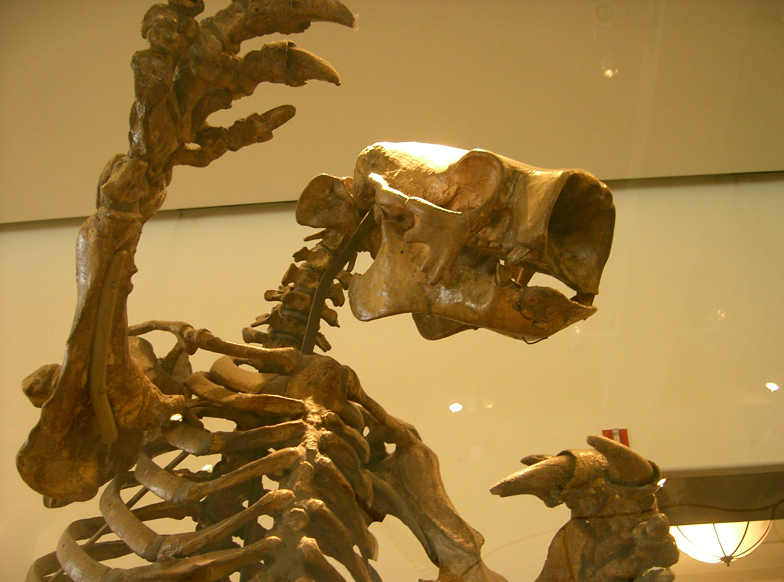
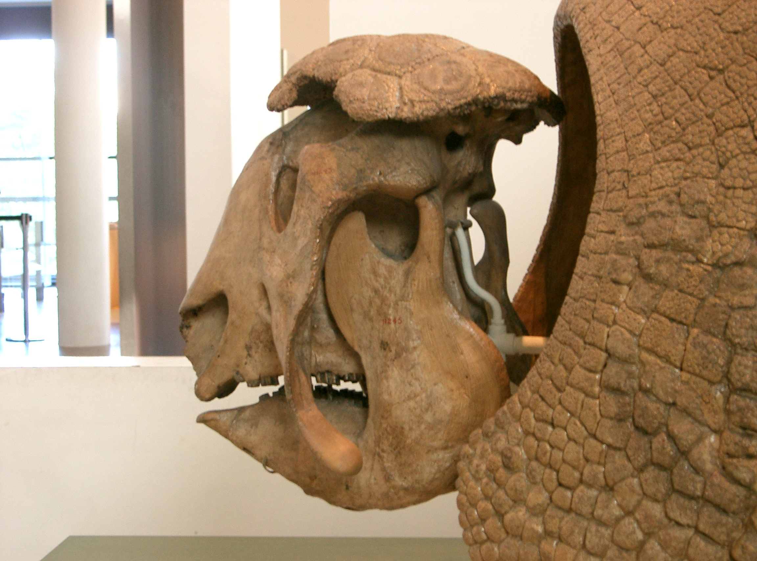

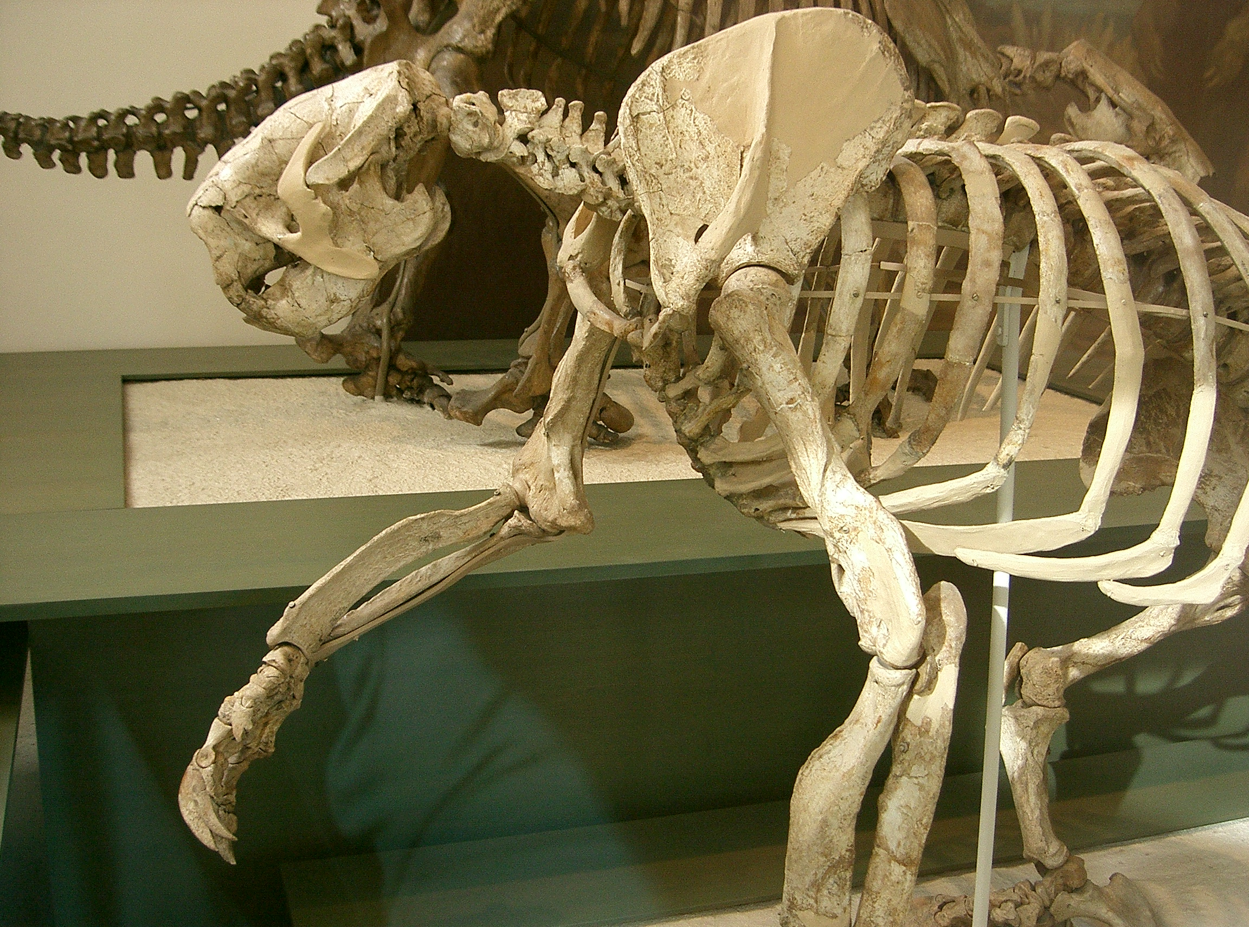
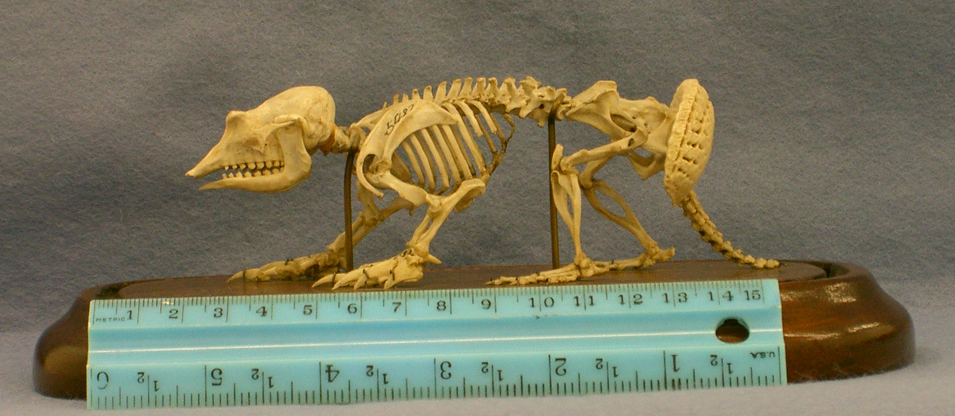
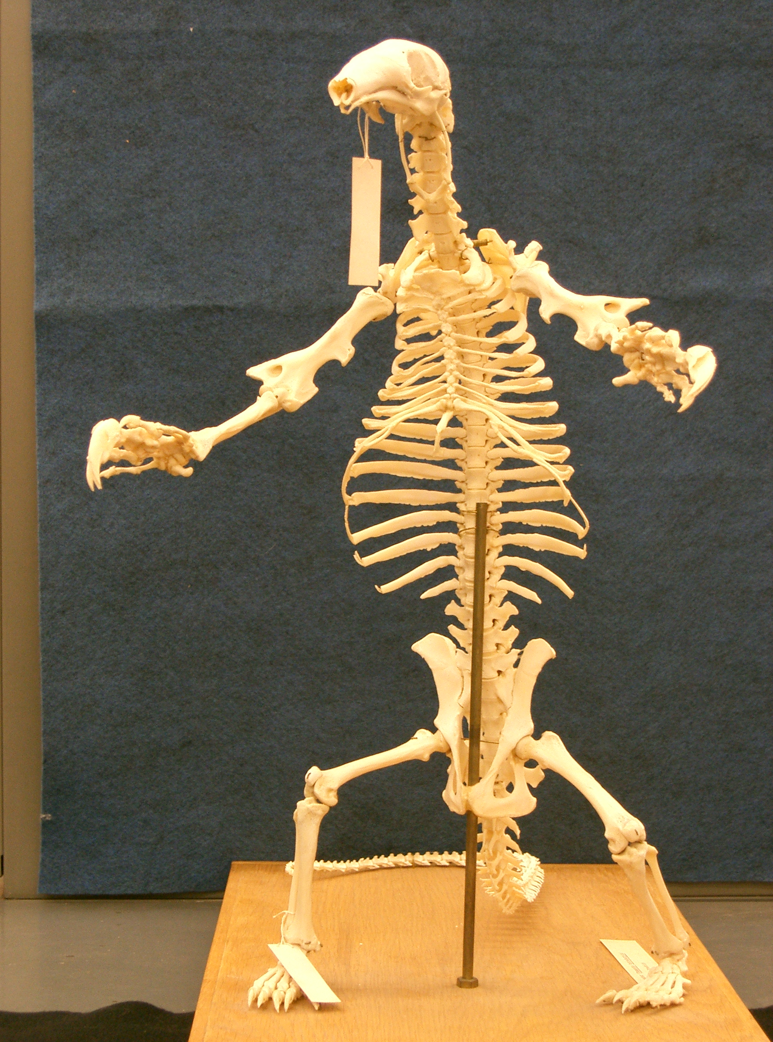

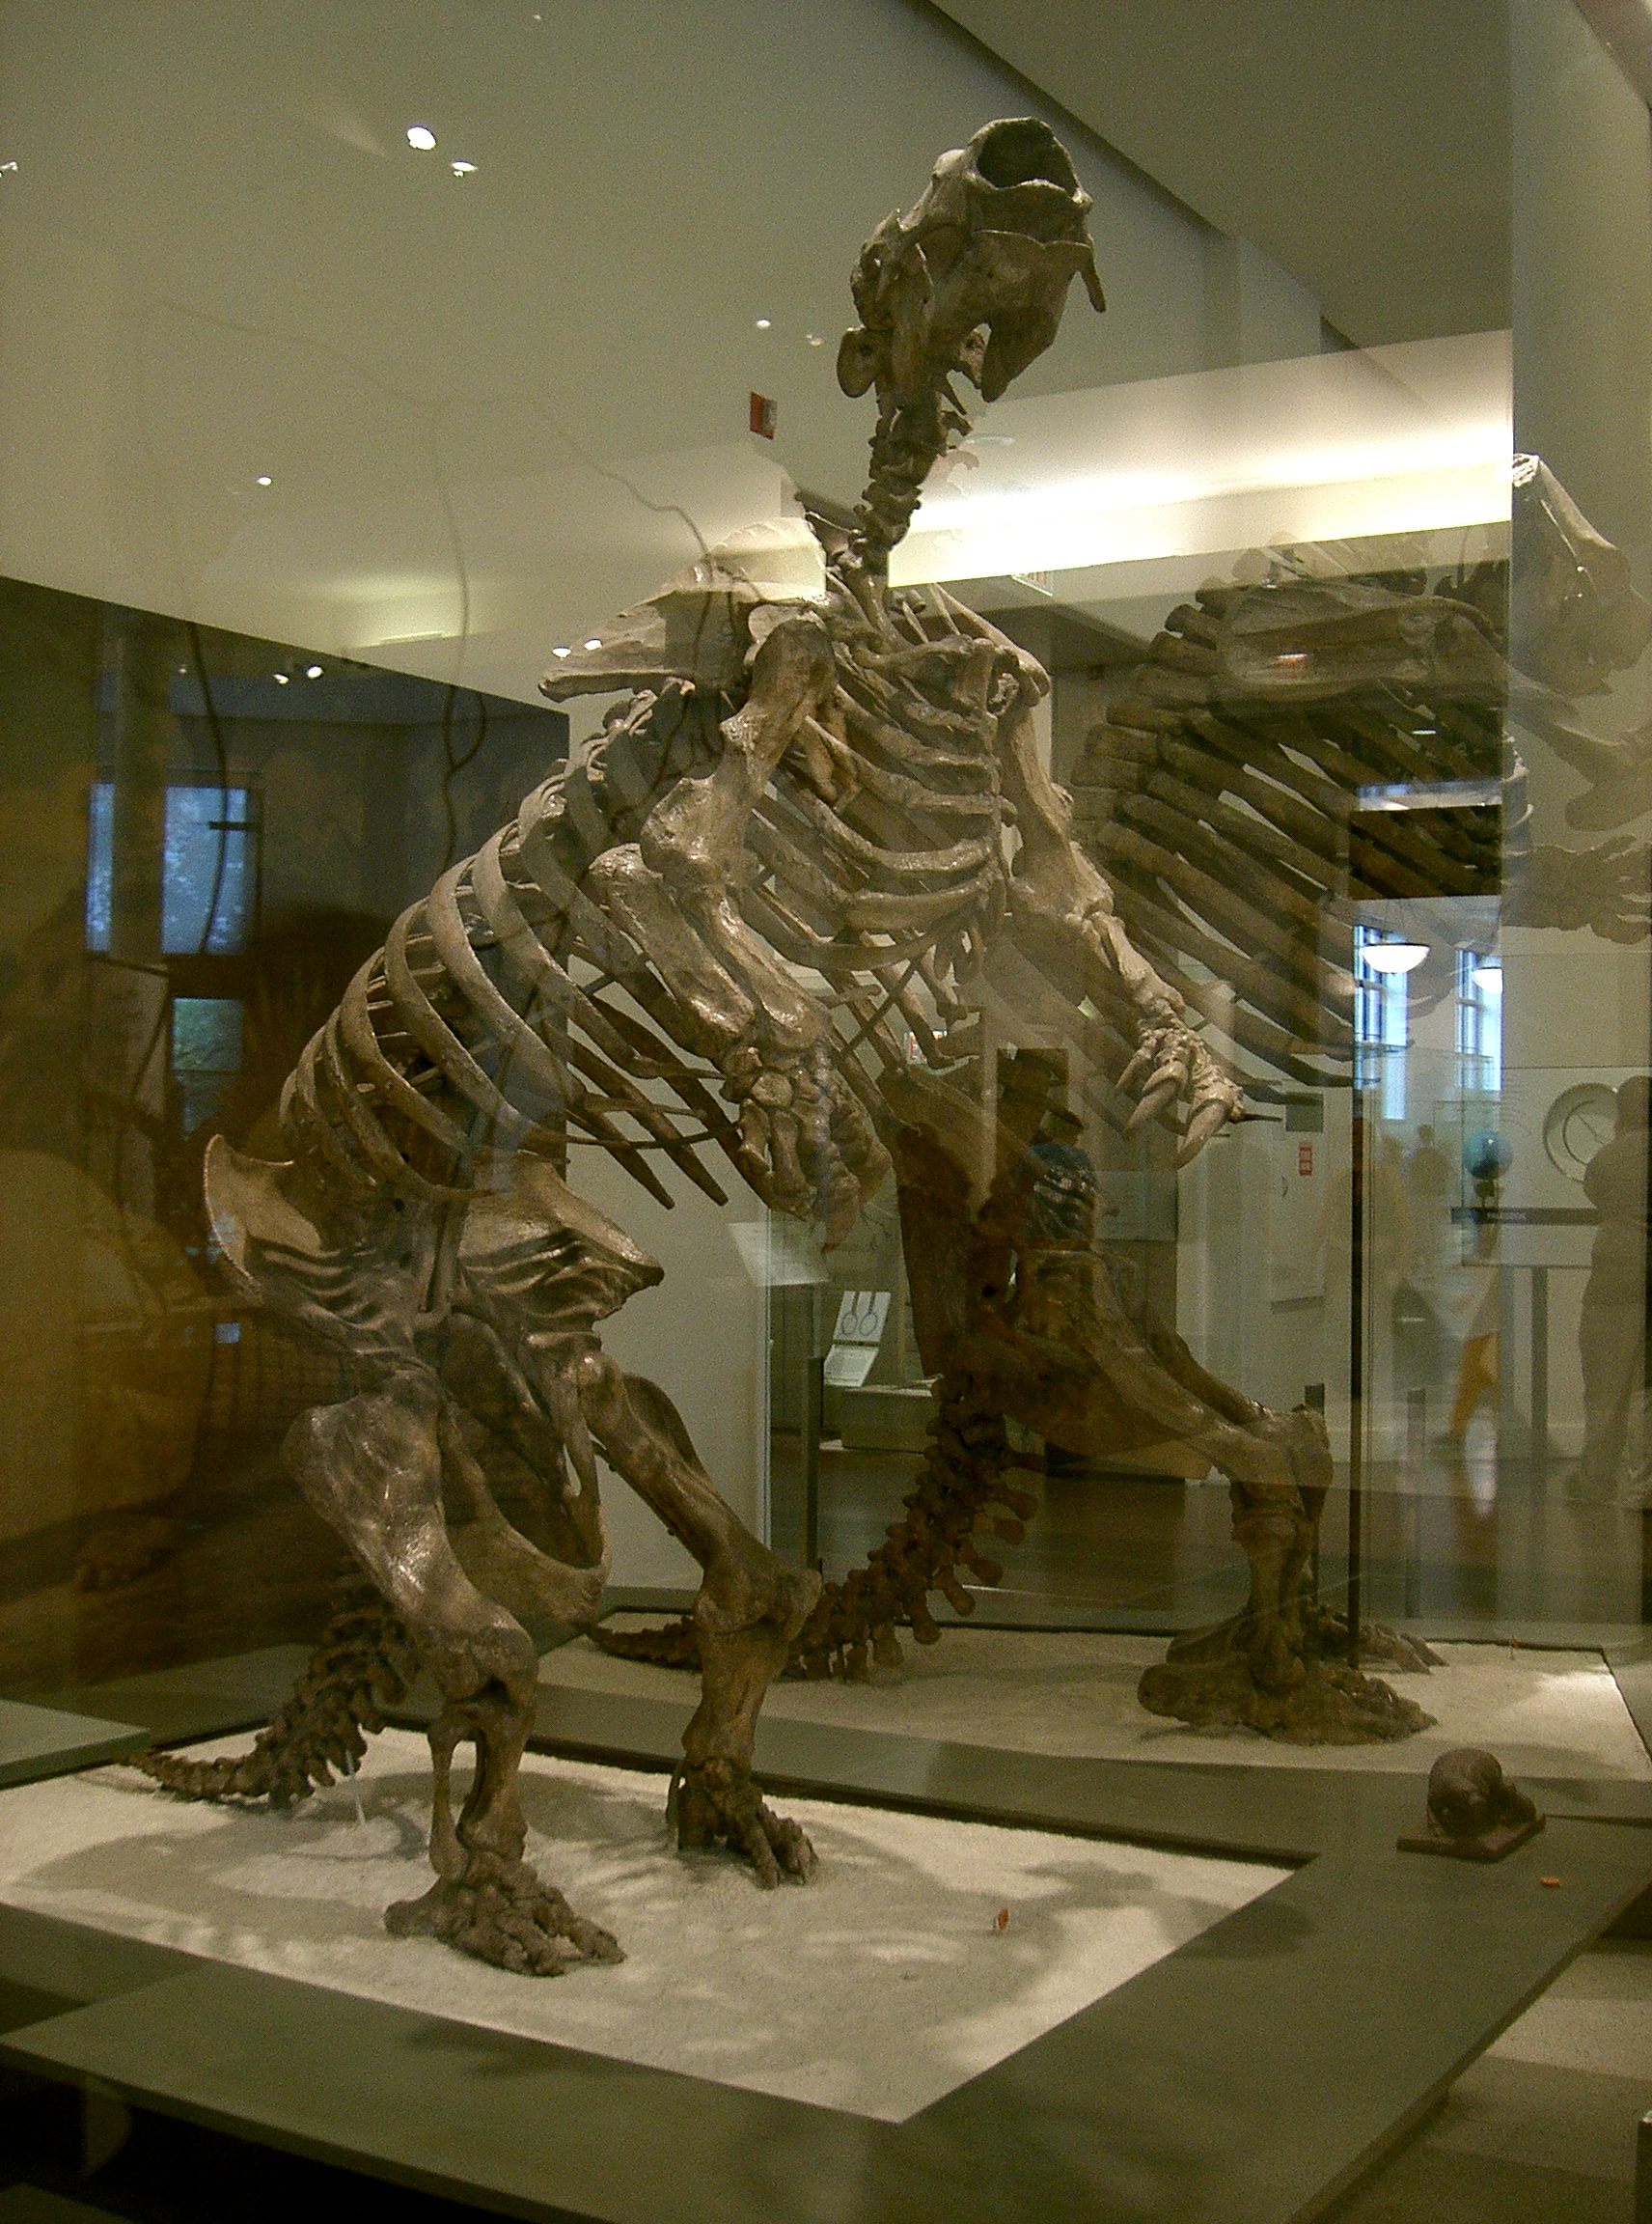

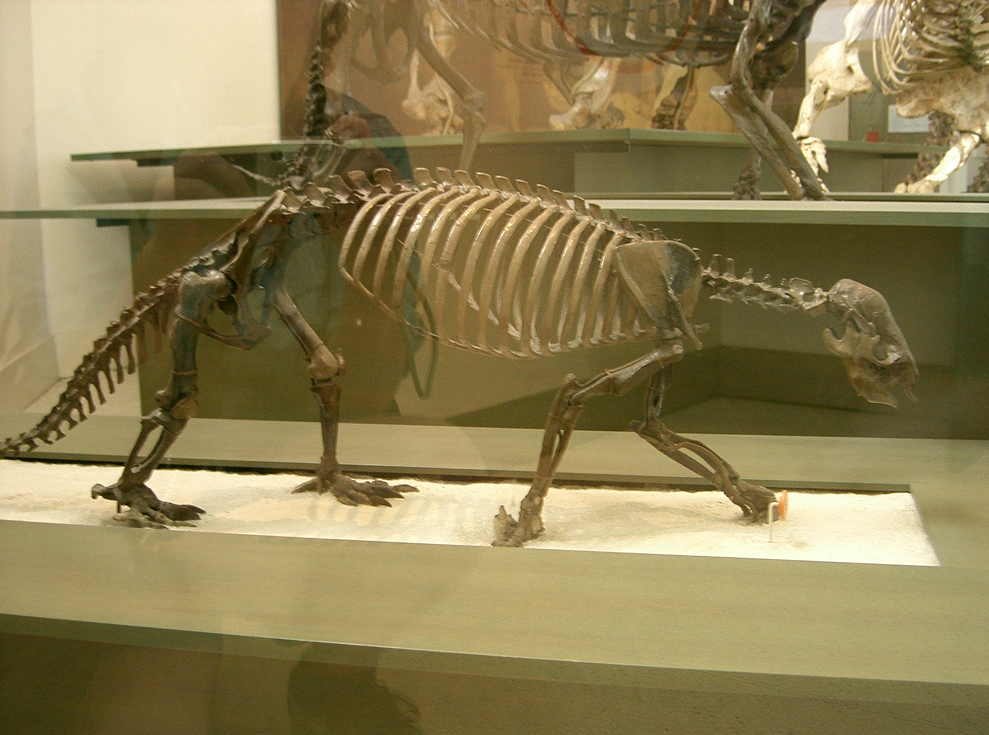

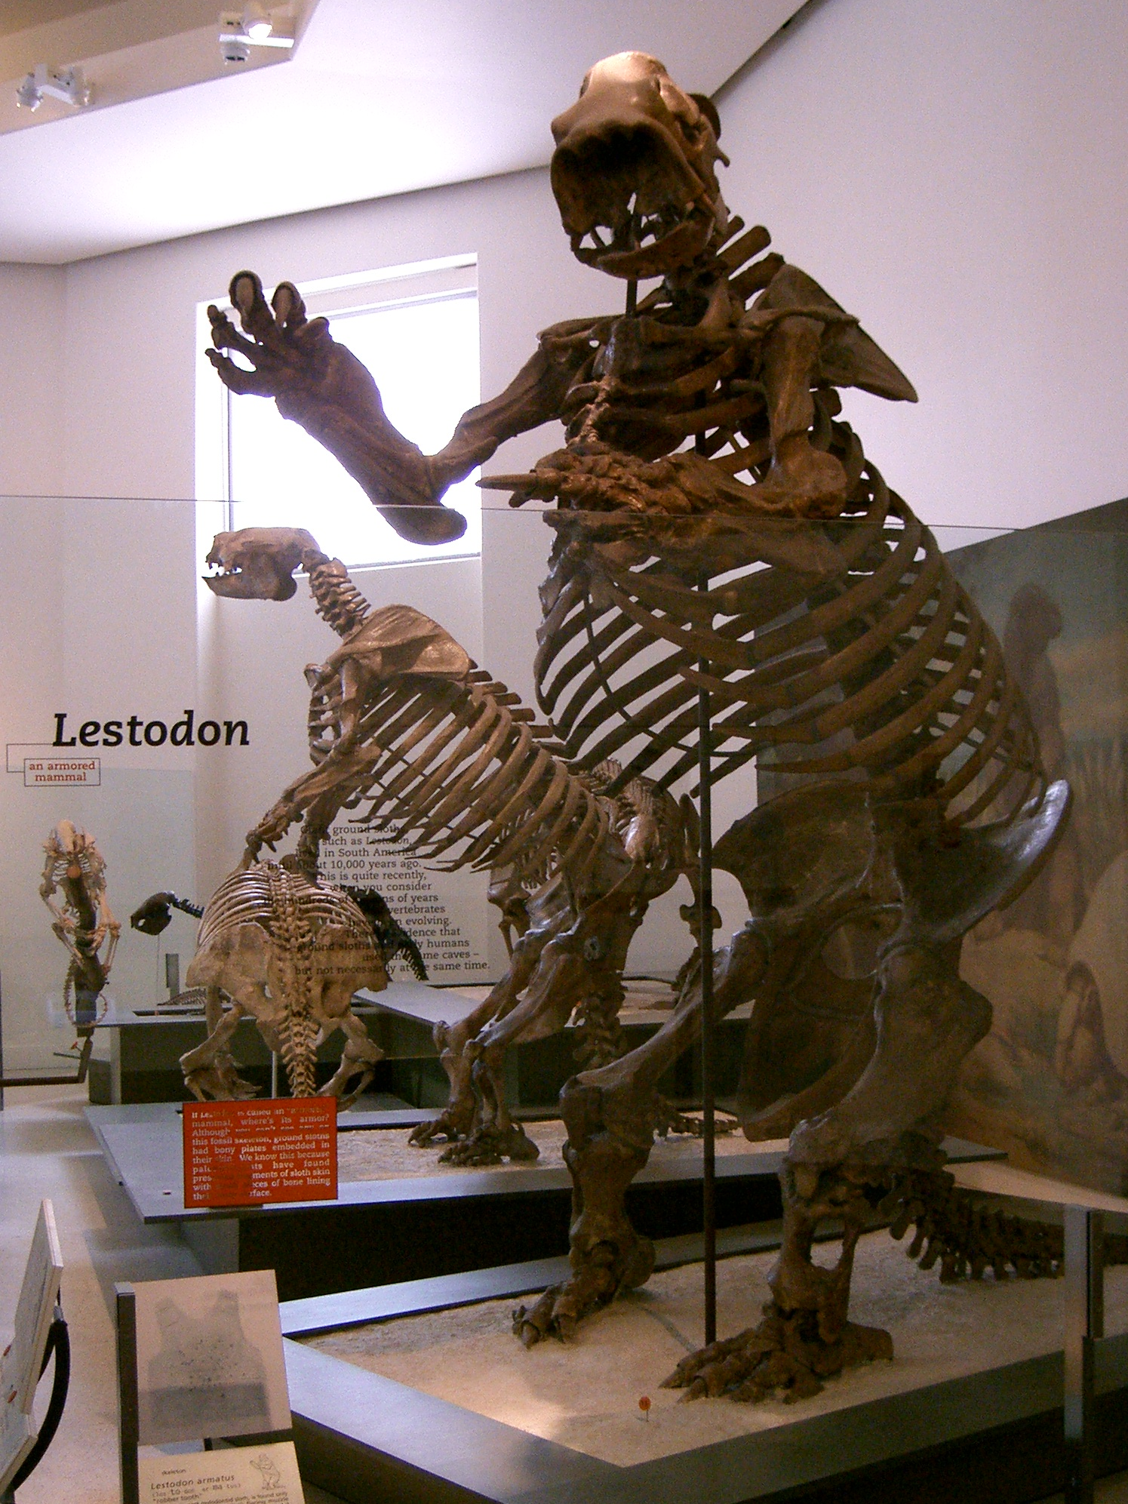

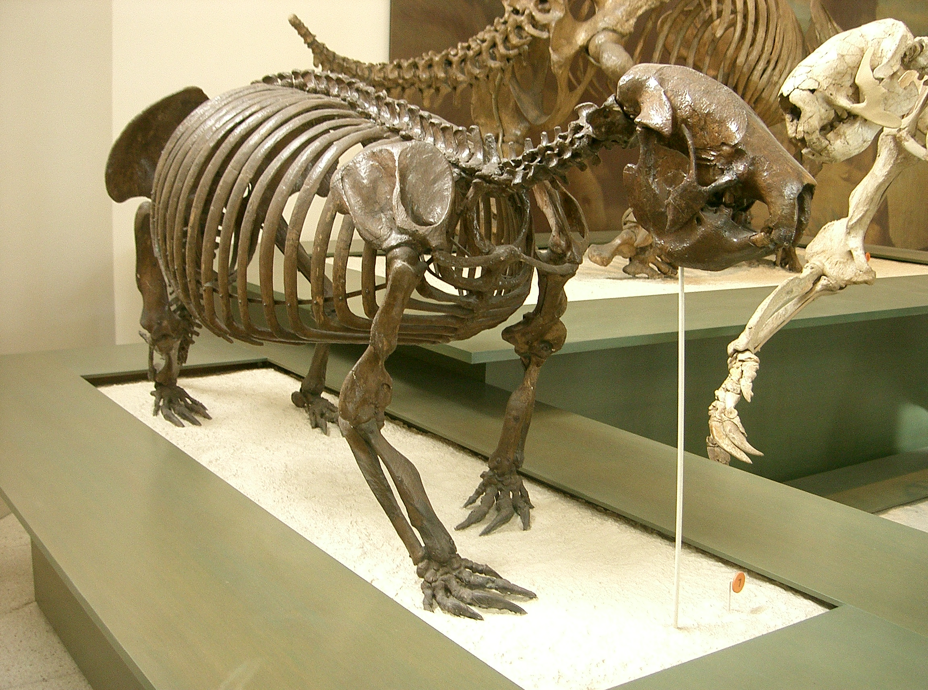
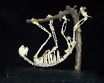

 | Page Number
Table of Contents  Myths | 1
Anteater Myths | 2
Armadillo Myths | 6
Sloth Myths | 9
Gound Sloth Myths | 11
Xenarthrans
Bradypus didactylus – pale-throated three-toed tree sloth | 13
Cabassous uncinctus – southern naked-tailed armadillo | 14
Catonyx tarijensis – ground sloth | 15
Choloepus didactylus – Linné's two-toed sloth | 16
Choloepus hoffmanni– Hoffmann’s two-toed sloth | 17
Dasypus novemcinctus – nine-banded armadillo | 18
Euphractus sexcinctus – six-banded armadillo | 19
Glossotherium chapadmalensis – ground sloth | 20
Glyptodon calvipes – glyptodont | 21
Holmesina septentrionalis – pampathere | 22
Megalonyx - ground sloth | 23
Myrmecophaga tridactyla – giant anteater | 24
Panochthus tuberculatus - glyptodont | 25
Priodontes maximus – giant armadillo | 26
Scelidodon – ground sloth | 27
Tamandua mexicana – northern anteater | 28
Unidentified – 7 small ground sloth crania and mandibles | 29
Out Group
Didelphus virginianus – Virginia opossum | 30
Tachyglossus aculates – echidna | 31
Information
Calipers | 32
Cenozoic Time, Stratigraphy, Superposition | 33
Family Trees - Phylogeny | 34
Skull and skeleton characters | 35
Skull specimen, museum number list | 36
Citations | 37

Myths

Myths about Anteaters
Anteater's Wisdom
- Ability to find lost objects
- Connection to the insect world
- Ability to smell out trouble before seeing it
- Understanding the value of "rooting around" to find solutions

Jaguar, Deer and Anteater
One day, a deer named Ciervos was wandering along a riverbank. "I am tired of wandering here and there," he said to himself. "I would like to build a house." He looked around. "And where could I find a better spot to build a house than here? This is where I will build.
So Ciervos went back into the woods, making plans to return.
Now on the same day, a jaguar called Jaguar was also wandering along the same riverbank. "I am tired of hunting here and hunting there," he said. "I would like to find a place to build a house and settle down." He looked around with surprise. "And where could I find a better place to build a house than here? This is where I will build."
So Jaguar left, making plans to return.
The next day Ciervos returned and started working on his house. With his great antlers he cleared the ground of all its bushes and shrubs. Soon he grew an appetite and returned to the forest.
While he was gone, Jaguar also returned. When he noticed that the ground had already been cleared, he roared with confusion. He looked left, and then right, then looked up with a smile of understanding. "The god Tupan must be helping me build my house. What a great fortune!"
So Jaguar built the floor of the house, then left for the evening kill, making plans to return.
The next day Ciervos returned and almost tripped on the floor. "The floor is already build. But…who…when…? He looked left, and then right, then looked up with a smile of understanding. "The god Tupan must be helping me build my house. What a great fortune!"
So Ciervos build the walls of the house and left, making plans to return.
The next day, Jaguar returned. "What a great job!" he said to himself as he admired the walls. He put on the roof of the house and left, making plans to return.
The next day Ciervos returned. "Tupan, it is beautiful!" he exclaimed. Ciervos then build two rooms in the house - one for himself and another in gratitude for Tupan. After he finished his work, Ciervos went to sleep in his own room.
That same night, Jaguar returned. "Two rooms in the house?" he remarked. Then he heard a sound. "Someone is snoring…It must be Tupan. I will take the other room." And Jaguar lay down for the night.
The next morning both animals woke up at the same time. It was hard to say who was more surprised when they came out of their rooms. Jaguar let out a roar! Ciervos stammered, "Did you help me build my house?"
"Did you help me build my house?" Jaguar retorted!
"Um, yes," Ciervos said warily.
"So, let's share it," Jaguar said.
Share the house with a jaguar? Ciervos thought to himself. But aloud he said, "OK."
So Ciervos lived in one room, and Jaguar lived in the other room.
One day, Jaguar approached Ciervos and said, "Please prepare the pots, water and a nice fire. I am going hunting now."
So Jaguar went deep into the woods. There, he stalked his prey. He followed it, hiding himself in the tall grass. At the right moment, he sprang forward and chased it after it. Roarrrrr! He killed his prey, which just happened to be a deer. He took the deer back to his house. When Ciervos saw what Jaguar brought home for dinner, he immediately lost his appetite. He entered his room, but he could not sleep. he feared that Jaguar would come and eat him also.
As Ciervos lay awake all night long, he came up with a plan. Early in the morning, he said to Jaguar, "Please prepare the pots, water and a nice fire. I am going hunting now."
"Hunting?" Jaguar said in surprise!
"Yes," said Ciervos.
So Ciervos went deep in the woods. There he found a huge jaguar sharpening his claws against the bark of a tall tree. Off to the right he spotted Tamandua Banderia.
Tamandua Banderia is a large anteater with a flaggy tail. Legend says that when this animal is aggravated it stands on its hind legs and gives a fatal embrace to its opponent - fatal because its curved and sharp claws pierce his opponent's lungs during the embrace.
Deer approached Tamandua and said, "Tamandua, that huge jaguar over there has been saying terrible things about you."
"Can't you see that I am eating now?" said Tamandua huskily. "Yum, yummy, yum, these ants are especially delicious."
"Tamandua," Ciervos repeated, "that huge jaguar over there has been saying terrible things about you, your sisters, your mother…the whole family!"
"Did you say my mother? Aaahhhh, just a second? Let me square something off with this huge jaguar!" He lumbered through the woods to the huge jaguar. "Hey huge jaguar!"
There was no answer. The huge jaguar continued to sharpen his claws.
"Hey huge jaguar!" he called again, louder this time.
The huge jaguar turned to face Tamandua. Quick as lightning, Tamandua embraced him, and that was the end of the huge jaguar.
After the deed, Ciervos picked up the huge jaguar's carcass and took it home. When Jaguar saw Ciervos dragging home dinner, he lost his appetite.
That night, neither Ciervos nor Jaguar could sleep. Each feared the other. There was no trust.
As the hours passed, they started to get tired. Deer's eyes began to close. Whey the did, his head nodded and his great antlers hit the wall with a loud noise Bam! When Jaguar heard the noise, he leapt up into the air, roaring with fear. When Ciervos heard the roar, he leapt up and ran out of the house along with Jaguar.
They took a quick look at each other. Ciervos ran east, and Jaguar ran west. and since that day, Deer and Jaguars have never lived together.
Brazilian tale as told by Antonio Rocha

The Star-eating Anteater
A magic carnival appears mysteriously over a single night and Licca has her adventures that play out almost dream-like. The structure of the story is similar to Midsummer Night's Dream or the Nutcracker. One of the strange sights they see is a transparent spirit-anteater but instead of ants it eats bouncing stars.

The Anteater, the Deer, and the Jaguar
A mother had three children. These children were all born with sharp teeth, claws, and an appetite for human flesh. The mother was concerned about the intentions of the children and their tools for destruction.
The mother asked her first child "Do you intend to eat human flesh?" The child was enthusiastic. The mother grabbed the child by the nose and stretched out its snout until it could no longer use its teeth. The sharp claws remained unrestricted. This child is Anteater.
The mother asked her second child the same question. The child answered, confirming its vicious intentions. The mother took the sharp claws and teeth and attached them to its head. This child is Deer.
The mother asked her third child the same question. The child did not say anything, so Jaguar was allowed to keep its claws, teeth, and appetite for human flesh.
paraphrased from the web page of The People of Manu

The mythological brothers Kamé and Kairu
Kamé was the first to come out from inside the earth after the deluge. Kamé and Kairu had different powers. Kamé worked during the day, and Kairu, on the other hand, worked at night. The sun belongs to the Kamé, and the moon belongs to Kairu. Kamé made the ming (the jaguar) during the day. Kairu was making another animal during the night. He had still not made its teeth, tongue and some toenails, when dawn was beginning to appear. Since during the day he had no power, he quickly put a thin stick in its mouth and said to it, “Since you have no teeth, will live eating ants. That is why the anteater, Tamanduá, is an unfinished and imperfect animal”(Borba 1882).

Mythical Beasts
In nature, there are, in the waters and the forest, visible beasts that can kill by simply touching. (Several of these beasts are similar to real animals and others aren’t, but all are believed to exist.) The most feared animals are the jaguars, like the kaokakoxi (two-headed jaguar), snakes and lizards. Among the beasts of the forest, these are considered the most dangerous, for they never die nor can they be killed, or something terrible will happen. The beasts are Kaokokoxi (lizard/two-headed jaguar); Kumepepyimo (centipede); Kutekute (black jaguar that looks like a puppy, but when you play with it, it grows in size and never dies); Kaikuxi Tymeremy (spotted jaguar); Kaikuxi Kapauimano (red jaguar); Maracajá (small jaguar); Maxipurimo (big anteater); Iou (big jaguar); Merimo (jaguar that stays on top of a tree); and Turupereimo (lizard/big snake that exists in the hills, the color of its tongue is like a macaw feather).
What differentiates these “dangerous” beasts from the rest? First, each one is, or can assume the monstrous form of its species. Second, all of them are “eaters of people” or cannibals. And third, they are found in places where the men also circulate, in the forest and river.

Spirits of the Lake
In the extreme east of the old R mkÇkamekra area there is a lake in the steppe called Lagõa Formosa by the Neobrazilians. At one time there was an island in the lake that constantly shifted its position. On it was standing a pindahiba tree, which inclined hither and thither till its top would nearly touch the level of the water.
Once a band of hunters moved past near the lake and saw a queer animal walking along on the steppe by the lake. It resembled somewhat the great anteater (Myrmecophaga jubata). At once one of the hunters pursued the animal, ready to shoot, but when he got near it his companions noted with amazement that he removed the arrow from the string, which he took off the stave and wrapped around the tip of his bow; then he shouldered the bow, and peaceably walked on with the beast. At once two other hunters, their weapons in readiness, pursued the animal and the man, but with the same result. As soon as they had caught up, they lowered their weapons, took them under their arms, and quietly walked beside the animal, which marched toward the lake with its three companions, and all together vanished from the sight of the hunting party.
Later, a band of R mkÇkamekra were again hunting in the vicinity of the lake and camped by its shore. Suddenly they saw an Indian carrying a slain deer on his back toward the lagoon. They thought he wanted to drink there, but he entered the water and disappeared. Soon they heard a noise below the water, then the sound of a dance rattle, and of dancers; after a while the noise died away. At the hour of nocturnal dancing the sound was heard again, and once more before dawn. Then the hunters in alarm abandoned the site, for they recognized that the lake was the dwelling of the souls of the dead.
Today Neobrazilians are living by the shore of the lake; the island with its pindahiba tree has vanished, and nothing more is heard of the spirits. Probably they have moved off since the arrival of the Neobrazilians.

Lost and Found
Father and Mother Anteater and their baby Alice were all resting near some bushes in the grasslands of South America. Father and Mother Anteater had long pointed noses and long pointed tongues, but their tails were thick ad bushy. As they rested, they spread their tails and covered themselves with the long, grayish fur. They looked as if they were resting under two grey tents. Alice was curled up beside them, dozing in the hot sunshine.
After a while Father and Mother woke up. They both felt hungry, and seeing that Alice was asleep they went off to look for some ants and other tasty insects. Before long Father smelt a nest and began digging with his sharp pointed nose, whilst his tongue shot in and out to catch the insects. Meanwhile Baby Alice woke and found she was alone. Uncurling herself, she set off to find her mother and father, but she went the wrong way. In no time she came to a village where she was soon captured by a little boy and put into a wooden crate.
Father and Mother Anteater went to the bushes where they had left Alice, but Alice wasn't there. Anxiously they sniffed with their long sharp noses until they found her trail, then they hurried after her until they came to the place where she was hidden.
All was quite in the village, everyone had gone to bed. Father and Mother Anteater tore at the wooden crate with their strong claws. Then, they poked with their long noses, until at last Alice was free. Back to the grasslands the little family hurried. Then they settled beside the bushes, spread their tails over themselves once more, and were soon fast asleep under their grey, furry tents.

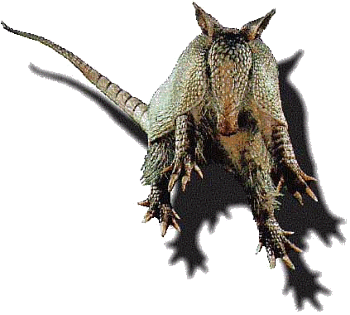
Myths about Armadillos
Armadillo's Wisdom
- Understanding your personal boundary
- Respecting the boundaries of others
- Carrying your protection with you at all times
- Understanding your vulnerabilities
- Empathy
- Discrimination

Armadillo
- Slow, sure animal
- No hurry – gets things right
- Keeper of the home

Symbol
The symbol of the armadillo means to "roll with the punches", and that is what we as a society should do also. Roll with the punches and get along with everyone despite differences in culture or opinion.

The Armadillo's Rancho
This story from Argentina tells of a wealthy Fox who tries to take advantage of a poor Armadillo, making her work his garden for him. He thinks he is getting the best part of the deal, but the Armadillo is smarter than he is at every turn and in the end succeeds in setting things right once and for all.

Silly Little Armadillo, Tolypeutes Folk Tale from Guiana
A long time ago, when the world was young, armadillos were happy friendly critters. They were loved by the raccoons; they were loved by the sloths; they were loved by the
The Lightning decided to kill all the armadillos. Why? Who can tell with that foul-tempered folk. A little armadillo named Tolypeutes, however, got wind of the terrible plan and went to the god Maluime, protector of all the animals, for advice. "Take away their strength," said Maluime. "Make them laugh!"
When the Lightning struck, all the armadillos buried themselves in the dirt shaking in their shells, so afraid that they just wanted to hide. Tolypeutes instead ran around sticking out his tongue and shaking his head. The Lightning laughed. Tolypeutes stood on his heads and waved his feet in the air. The Lightning laughed even harder. Then, Tolypeutes rolled into a tight ball, and the Lightning kicked him around, playing a game of soccer. The Lightning laughed so hard, tears poured out of their eyes like a river. The ground became wet, and worms wriggled and squirmed out of their hiding places. The armadillos hiding in the dirt jumped straight up into the air with glee. They forgot all about the Lightning and merrily began to eat those slippery, slimy worms with relish and a slurp. The Lightning fell over laughing so hard at the silly little armadillos. The Lightning picked themselves up, dried off their eyes, and when back to the sky world, giggling at that silly Tolypeutes, and all of the armadillo antics. And that is how armadillos taught people that the best way to fight an enemy is to make them laugh. And it is also why worms are still armadillos' favorite food.

The Painted Jaguar First published in the Ladies’ Home Journal, May 1900
Stickly-Prickly Hedgehog and Slow-Solid Tortoise lived on the banks of the Amazon River. Painted Jaguar also lived there. He was told by his mother how to catch hedgehogs and tortoises so that he could eat them, by dropping the Hedgehog into water and scooping the Tortoise out of his shell. He found them, and the Hedgehog curled up while the Tortoise hid in his shell. Painted Jaguar repeated his mother’s advice and asked them which of them was which. They answered by scrambling her words until the Jaguar was thoroughly confused.
He tried to scoop out the Hedgehog and got his paw full of prickles. Then he argued with the Tortoise till he was even more confused, and told the Tortoise to jump into the water, whereupon the Tortoise swam away. He turned his mother’s instructions into a rhyme to help him remember. The Hedgehog and the Tortoise overheard, and decided to share their skills, the Tortoise learning to curl up and the Hedgehog to swim.
In the process, both were changed, so that the Hedgehog’s prickles became armor and the Tortoise’s shell grew flexible. They sought out Painted Jaguar and rolled around him till he was dizzy. He complained to his mother, who told him to call the new animal “Armadillo” and to leave it alone. So he did.

Rebellious Gods
There is a Mayan legend that describes an event where two rebellious gods were taught a lesson. The legend says that the Mayan Sun God sat the two unruly gods down on a bench before all the other gods. The bench was suddenly altered into a pair of armadillos, which immediately jumped up in the air--tumbling the two disobedient gods onto their backsides in disgrace

Bacabs
Itzamn was the principal pre-Columbian Mayan deity. The ruler of heaven, day, and night, he frequently appeared as four gods called Itzamn·s, who encased the world. Like some of the other Mesoamerican deities, the Itzamn·s were associated with the points of the compass and their colours (east, red; north, white; west, black; and south, yellow). Itzamn· was sometimes
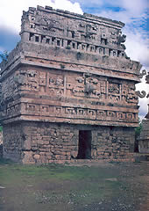
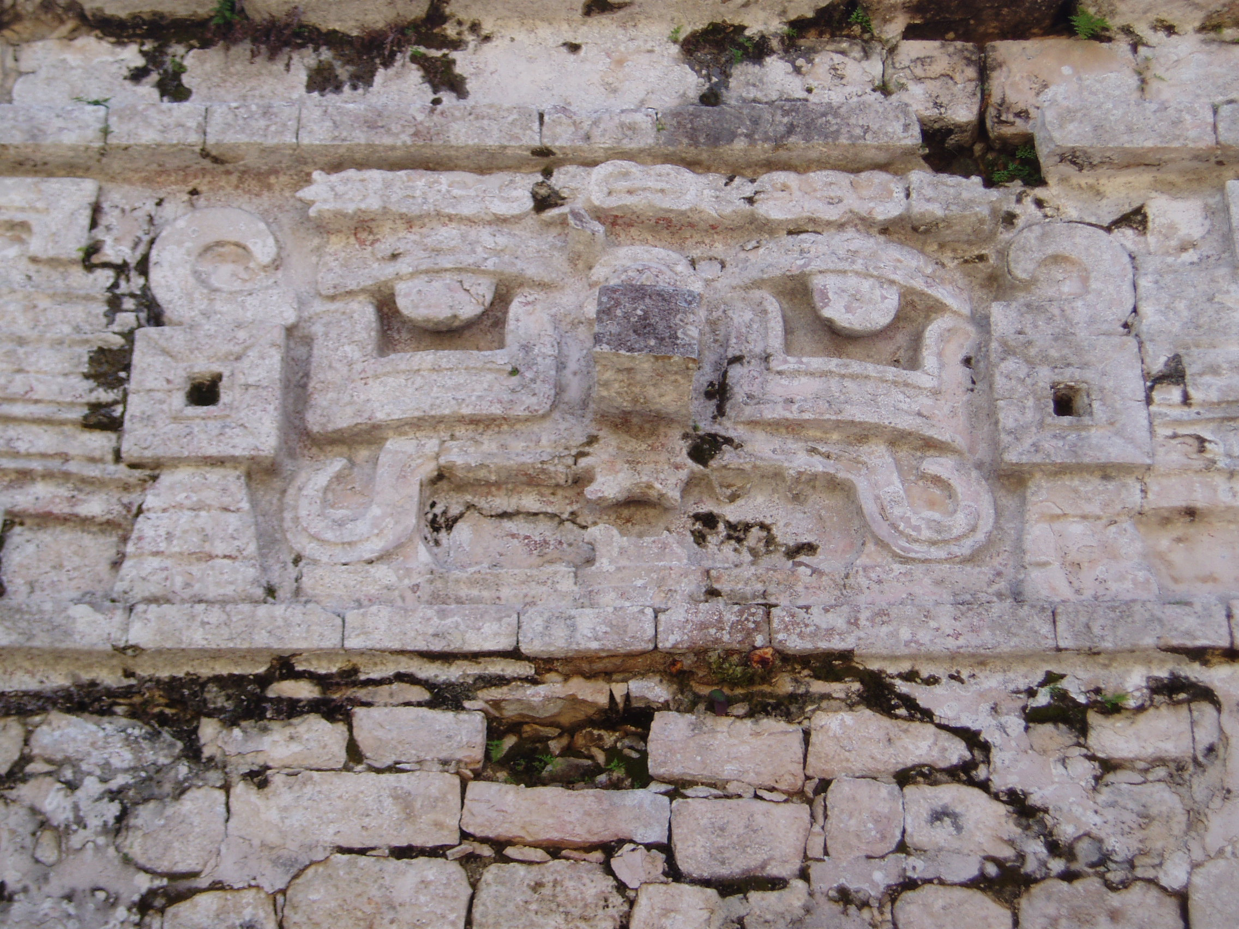
identified with the remote creator deity Hunab Ku and occasionally with Kinich Ahau, the sun-god. The moon goddess Ixchel, patroness of womanly crafts, was possibly a female manifestation of the god. Itzamn· was also a culture hero who gave humankind writing and the calendar and was patron deity of medicine. Itzamn and Ixchel had 4 children (in some stories, they had one child who could appear as four animals) called the Bacabs, an armadillo, a tortoise, a crab, and a snail.
These brother gods held up the sky with upraised arms. They each had assigned positions at the four cardinal points of the compass. The center was blue-green. The north was white, east was red, south was yellow and the west was black. Finally, the earth was supported on the back of a crocodile.

Foretelling the Future
Queen Móo while yet a child consulted an h-man (wise man) wearing his ceremonial mantle of blue and yellow feathers. She was seated on the back of a peccary under the royal umbrella of feathers, and next to her was the wing serpent. She listened with profound attention to the decrees of fate as revealed by the cracking of the shell of an armadillo exposed to a slow fire on a brazier, the condensing on it of the vapor, and the various tints it assumed. This mode of divination was one of the customs of the Mayas.

Myths about Sloths
Sloth's Wisdom Includes
- Wisdom associated with moving slowly
- The value of laziness
- Understanding the tree spirits
- Ability to access the libraries within the trees where all Earth knowledge is held
- Seeing the world upside down
- understanding when to use tenacious behavior

Superstitions
There are many superstitions about sloths in Peru. One of which says that if a mother eats a sloth, her children after that will either die or be lazy and amount to nothing. Because of this myth, mothers will abstain from eating a sloth until she is done with her childbearing years.

Sun and Moon’s Children
Cupara and his wife are the parents of the sun, for whom they created the moon from mud to be his mate. The children of the sun and moon are the animals, and among the animals is the sloth, who was the ancestor of the Jivaro.

Star People
Long ago, the sky lay low to the ground and was attached by its umbilical cord to the earth. One day a group of Machiguengas decides to climb up the cord and capture the star people, who lived in the sky. As the Machiguenga group was climbing up, one of the sky people, called toucan man, looked down from his perch. He clipped the cord with his beak, causing the raiding party to fall towards the earth. The leader of the group, who was highest up, changed himself into a cacique bird and saved himself. His companions following behind also saved themselves by turning into ground dwelling flightless birds. The others bringing up the rear were not so lucky as they fell to earth; one impaled himself with the arrows he carried, another got tangled in his climbing rope, fell and stunned himself and became the slow moving sloth. Others fell into trees and lakes and became many other animals of the forest. The sky, thus disconnected from the earth by its umbilical cord, floated high up into the sky where it remains today, out of reach of ordinary humans.

Geronimo the Sloth
Geronimo the sloth hung upside-down, swinging by his toes from a branch of a tall tree in the deepest part of the forest. "Wake up, Geronimo," shouted the parrots. "Don't hang there dreaming all day!" Geronimo replied in a slow, deep rumble, "I am wide awake, thank you - thinking very deep thoughts." At this the parrots chattered with laughter, "You're just a lazy, stupid good-for-nothing. You will never do anything important hanging upside-down." "Who wants to do anything important?" asked Geronimo. "I don't. I am just happy to swing here, and look at the sky." The parrots flew away in disgust. But Geronimo was not lazy or stupid. He watched everything that went on in the forest, and thought deeply about it.
That summer, the river dried to a muddy trickle. There was no rain. All the trees and grasses were drying up in the heat. "Parrots-listen," called Geronimo, "I smell danger." The parrots ignored him. "There will be a forest fire soon," said Geronimo in a very serious voice. "I have thought it all out. The trees and the grass are dry. They will burn easily. It is time for us all to move." Saying this, Geronimo swung off his branch, and began his slow journey away from that part of the forest. When the parrots saw Geronimo leaving, they realized he must be speaking the truth, so they too flew off to find a new home where there was less danger of a forest fire. Some days later, Geronimo and the parrots reached a place where the river was deep again, and wide. Geronimo crossed it on a floating log. As he reached the opposite bank, the parrots saw smoke and flames far away in the distance. "Thank you, Geronimo," said the parrots. "We will never call you stupid or lazy again. Without your deep thoughts, we would never have been saved."

Sloth to the Rescue
Once upon a time there was a sloth. All sloths are lazy animals who live in trees. The other animals of the forest knew that sloths were lazy, but they all thought that this sloth was the largest and laziest of them all, and quite good for nothing. One day a bird flew into the tree and built her nest beside Sloth. While she sat on her eggs, she twittered to him and sang, making him very happy. He would nibble at nearby leaves and fruit, and listen to the little bird's song, but he was much too lazy to talk to her.
One day, when the baby birds had hatched from the eggs, the mother flew off to find some food. "Take care of my babies," she called to Sloth, but he didn't bother to answer. While Sloth dozed on his branch, a snake came slithering up the tree looking for baby birds to eat for supper. All around monkeys chattered and birds cheeped warnings, but lazy Sloth slept on. Nearer and nearer slithered the snake, not noticing Sloth, so still and green as he hung among the leaves. When the snake saw the baby birds, he hissed a loud hiss right in Sloth's ear. Sloth woke up, for he hated hissing noises, unless he made them himself. He was so angry that he opened his eyes, and saw the slippery snake about to snatch the babies from the nest. Unhooking one hand, he clawed at the snake, who was so surprised that he fell out of the tree and slithered away home. Then all the birds and monkeys were proud of Sloth, for he was useful, after all.

Myths about Ground Sloths:
The deep Amazon jungle of Brazil provides the backdrop for tales of the Mapinguari, a large nocturnal animal with a frightful screaming cry. Locals describe the Mapinguari as about two meters in height when standing on its hind legs. It is covered in red hair and emits a foul odor. Its feet are turned backwards and its claws are capable of ripping apart the palm trees upon which it feeds.
Ornithologist David Oren believes the Mapinguari is real. He has searched for it for twenty years. Oren suggests the Mapinguari is a surviving ground sloth, similar to the (presumably extinct) Mylodon . While the smaller tree sloths still exist, ground sloths are generally assumed to have died out around ten thousand years ago. So far no tangible evidence of the Mapinguari has survived close scrutiny.
Oren is not the first to suggest that giant ground sloths still exist. In the 1890s Ramon Lista, an Argentinian explorer, encountered a large unknown animal while hunting in Patagonia. Lista tried to shoot the animal but bullets apparently had no effect. Paleontologist Florentino Ameghino heard Lista's story. He was already familiar with descriptions of such a creature reported by Native Americans in Patagonia. They reported that arrows penetrated the creature's skin only with difficulty. Ameghino posited the creature might be a surviving ground sloth. Preserved skin samples from prehistoric ground sloths showed hard dermal ossicles that would have protected against prehistoric predators and, possibly, arrows and bullets as well. Ameghino named the purported modern ground sloth Meomylodon listai in Lista's honor.
Possibly the Mapinguari, if it exists, is not a giant ground sloth but an unknown large species of anteater. Anteaters and sloths are related animals. The well-known giant anteater Myrmecophaga tridactyla can reach a length of two meters and weigh nearly 40 kilograms. An anteater twice this size might be a candidate for Mapinguari.
Should the Mapinguari turn out to be a giant ground sloth it would not be the first such presumably extinct ice-age mammal to be found still alive in South America. In the early 1970s Ralph M. Wetzel and co-workers from the University of Connecticut discovered living specimens of the Chacoan Peccary, which he named Catagonus wagneri. Peccaries are close relatives of pigs and boars. Prior to Wetzel's find this type of peccary was known only from fossils and had been thought to have died out ten thousand years ago. Wetzel found the living specimens in Patagonia after hearing native stories. The natives called it the tagua. The Chacoan Peccary is the largest of the three known living species of peccary. There are significant differences in the chromosome numbers of the Chacoan peccary and the other two species, indicating they are not closely related. Very little is yet known of the Chacoan peccary's life cycle. It is considered to be an endangered species.
http://www.pibburns.com/cryptost/mapingua.htm

RIO DE JANEIRO, Brazil (AP) -- It's huge, smelly and cries like a human being. And it would be the biggest mammal in the Amazon -- if it exists. The giant sloth, a relative of an extinct great sloth that lived 8,700 years ago, has been reportedly sighted across the region. On Tuesday, an American zoologist -- armed with a shotgun and an oxygen mask -- set off to search for the animal. ``The number of details in reports of sightings makes me believe it does indeed exist,'' David Oren told The Associated Press in a phone interview Monday night from his office at the Goeldi Museum in the eastern Amazon city of Belem. Oren, who will search for evidence in the rain forest of the northwestern state of Rondonia, believes he can find the animal, or at least the bones of one reportedly killed late last year by gold miners. Oren said he planned to spend three weeks searching for the carcass of the sloth, which allegedly was 6 feet long and weighed 660 pounds. From Belem, Oren was flying to Rondonia's capital of Porto Velho, 2,320 miles northwest of Rio de Janeiro. Then, he planned to continue by bus and on foot for about two days to reach the jungle farm where the sloth was reportedly killed. Oren, of Boston, said he had arranged a meeting with the miners who claimed to have killed the sloth. ``Hopefully they will be able to find the spot where they left it,'' the 40-year-old zoologist said. Much smaller tree sloths, about the size of a house cat, live in tropical Central and South America. Sloths are slow-moving, tree-dwelling mammals that hang upside down from branches and feed on leaves and fruits.
In reporting the giant sloth, people across the Amazon have described the same feces, eating habits, behavior, and bedding, he said. According to most accounts, it eats palm-tree hearts and other foliage, and becomes aggressive if its habitat is invaded. Oren interviewed Canamari Indians in the Jurua valley of Amazonas state, north of Rondonia, who raised two infant sloths on bananas and milk when hunters scared off the mother. ``Later, they were given foliage, and after one or two years the unbearable smell of their skin prompted the Indians to release them,'' Oren said. Oren thinks the fetid smell reportedly exuded by the animal comes from a badly functioning stomach gland. He and his guide will take along oxygen masks and shotguns on their search. It is widely believed among the Canamari that the giant sloths are still alive. Canamari hunters say they see them occasionally, he said. The sloth reportedly emits sounds like human beings, Oren explained. Tales have it that rubber tappers and hunters confuse the cries of the sloth in the jungle with those of a person. The giant sloth is often associated with the Mapinguari, a mythical beast. According to legend, the Mapinguari was a shaman who wanted eternal life and was transformed into a monster.
4021 Bradypus tridactylus
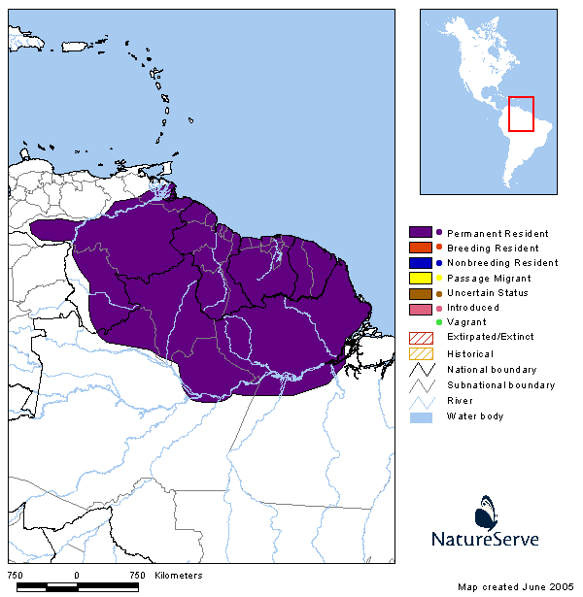
pale-throated three-toed sloth

Domain: Eukarya
Kingdom Animalia
Phylum Chordata
Subphylum Vertebrata (Craniata)
Class Mammalia
Subclass Theria
Infraclass Eutheria
Clade Xenarthra
Superorder Xenarthra
Order Pilosa
Family Bradipodidae
Bradypus tridactylus

Mass: 2.25 to 5.50 kg
(4.95 to 12.1 lb.)
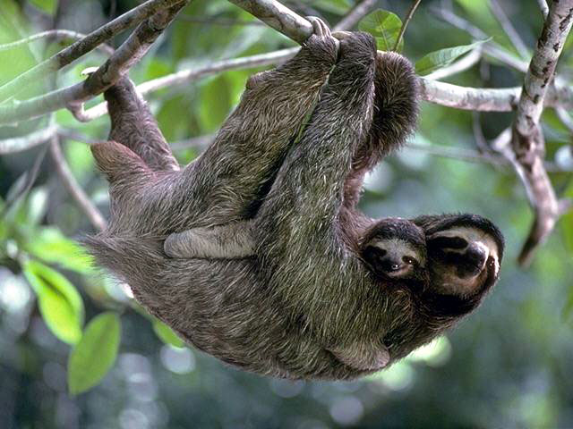

4022 Cabassous uncinctus
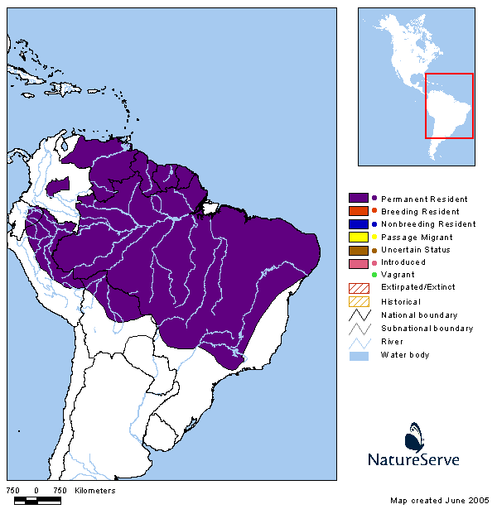
southern naked-tailed armadillo

Domain: Eukarya
Kingdom Animalia
Phylum Chordata
Subphylum Vertebrata
Class Mammalia
Subclass Theria
Infraclass Eutheria
Clade Xenarthra
Superorder Xenarthra
Order Cingulata
Family Dasypodidae
Cabassous uncinctus
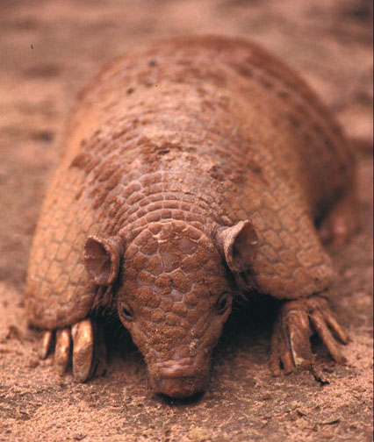
Mass: 2 to 3 kg
(4.4 to 6.6 lb.)

4023 Catonyx tarijensis
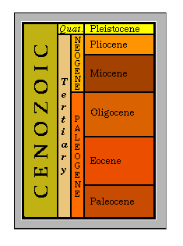

Mylodontid ground sloth

Age: Pleistocene
Found: Bolivia

Domain: Eukarya
Kingdom Animalia
Phylum Chordata
Subphylum Vertebrata
Class Mammalia
Subclass Theria
Infraclass Eutheria
Clade Xenarthra
Superorder Xenarthra
Order Pilosa
Family Mylodontidae
Catonyx tarijensis
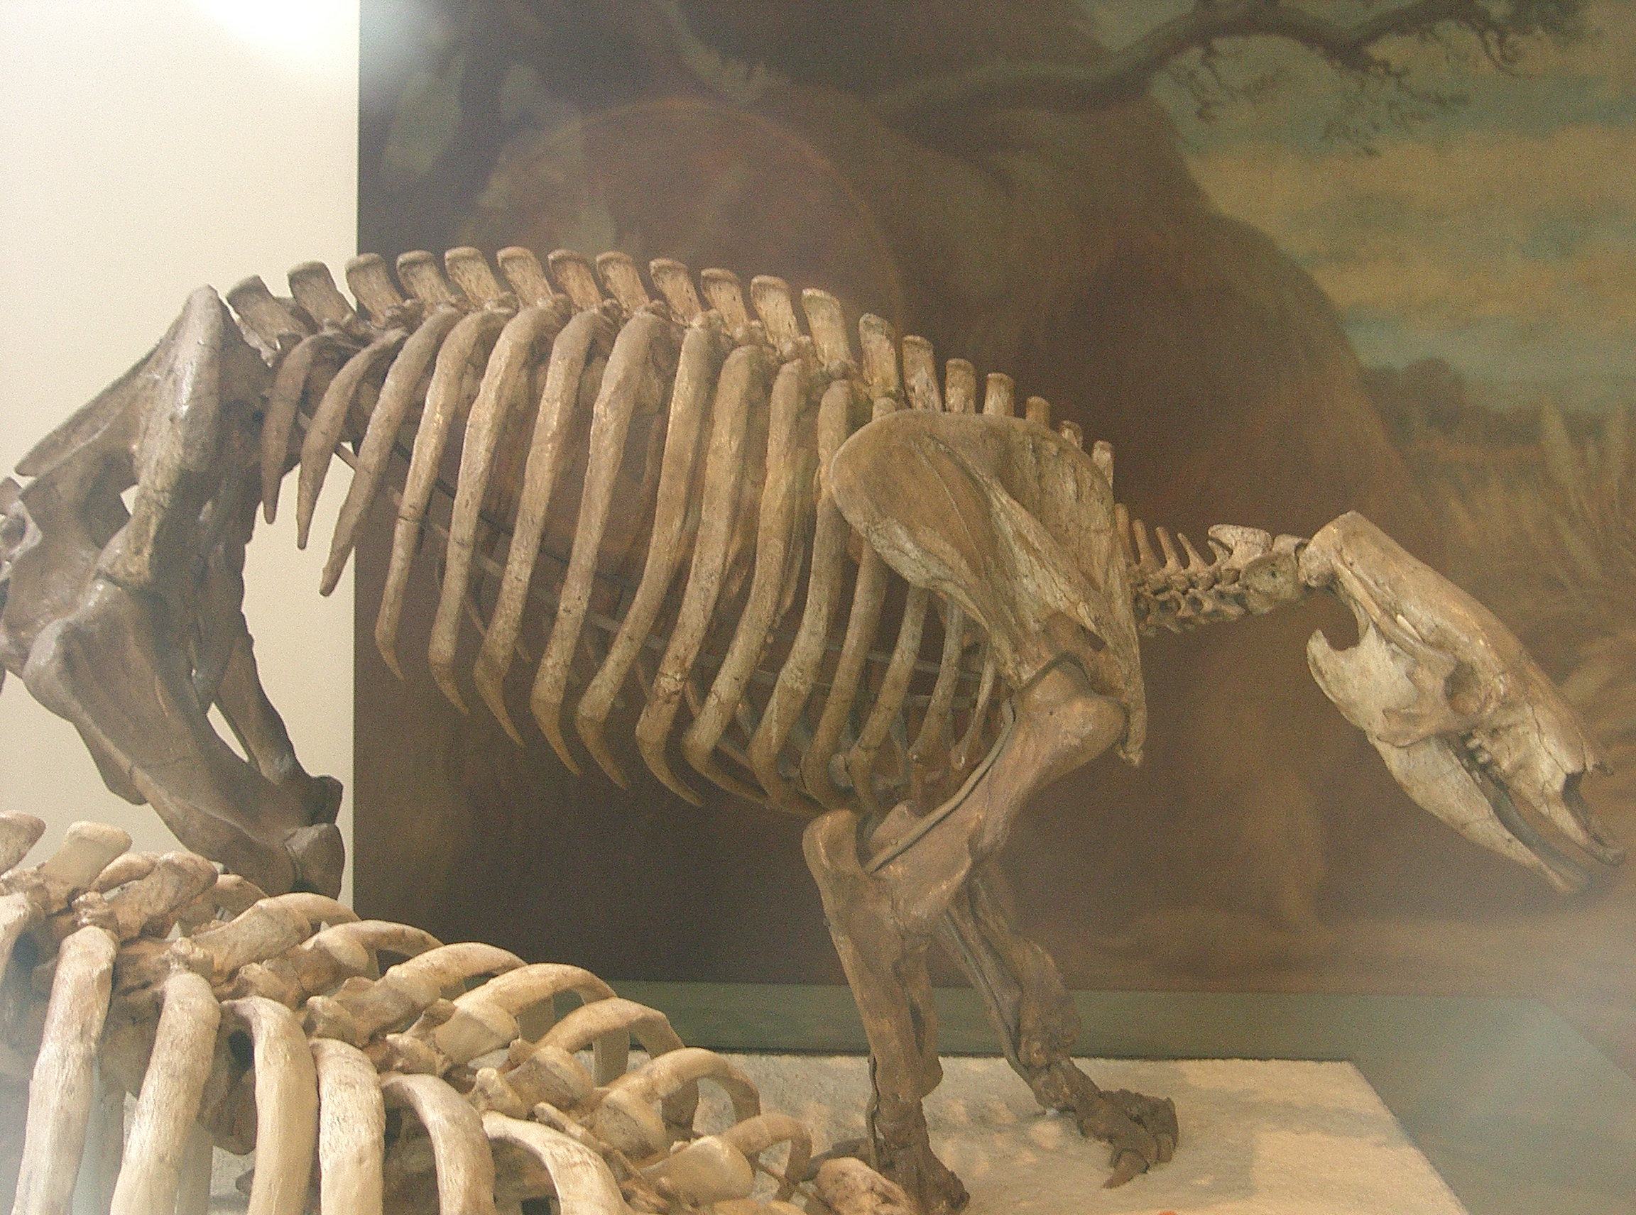

4024 Choloepus didactylus
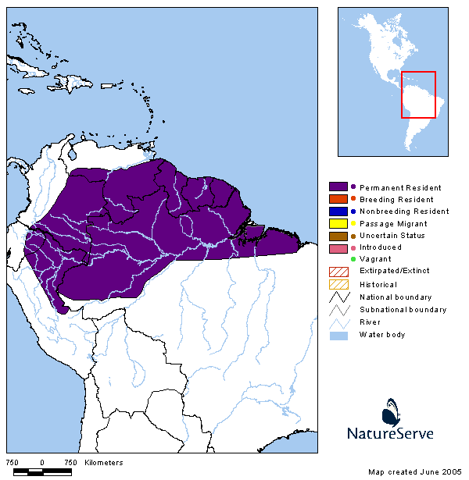
Linné's two-toed sloth

Domain: Eukarya
Kingdom Animalia
Phylum Chordata
Subphylum Vertebrata
Class Mammalia
Subclass Theria
Infraclass Eutheria
Clade Xenarthra
Superorder Xenarthra
Order Pilosa
Family Megalonychidae
Choloepus didactylus
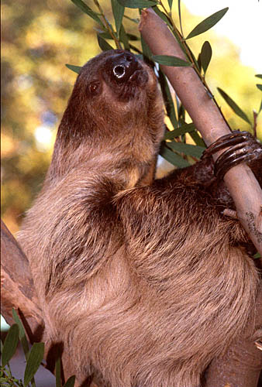
Mass: 4-8 kg
(8.8-17.6 lb.)

4025 Choloepus hoffmanni
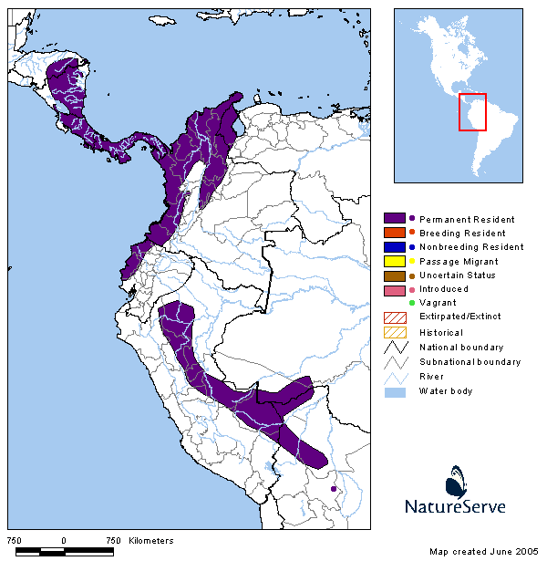
Hoffmann's two-toed sloth

Domain: Eukarya
Kingdom Animalia
Phylum Chordata
Subphylum Vertebrata
Class Mammalia
Subclass Theria
Infraclass Eutheria
Clade Xenarthra
Superorder Xenarthra
Order Pilosa
Family Megalonychidae
Choloepus hoffmanni

Mass: 5.7 kg
(12.5 lb.)
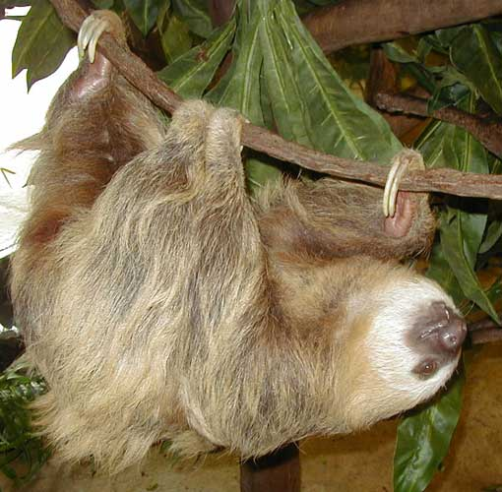

4026-4040 Dasypus novemcinctus
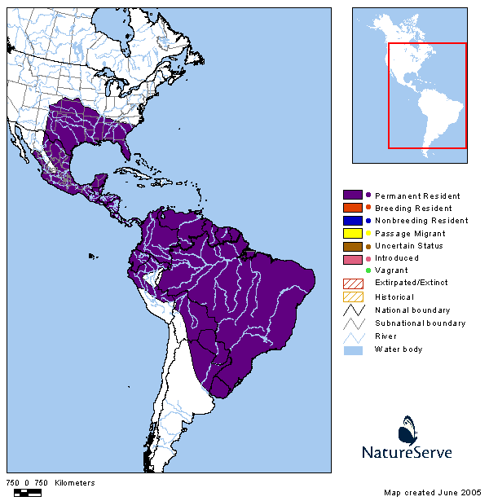
nine-banded armadillo

Domain: Eukarya
Kingdom Animalia
Phylum Chordata
Subphylum Vertebrata
Class Mammalia
Subclass Theria
Infraclass Eutheria
Clade Xenarthra
Superorder Xenarthra
Order Cingulata
Family Dasypodidae
Dasypus novemcinctus

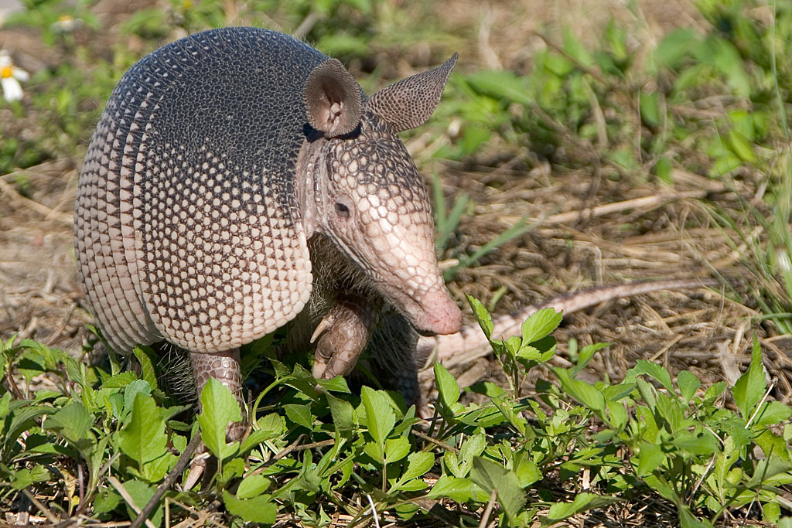
Mass: 3.6-7.7 kg
(7.9-16.9 lb.)

4046 Euphractus sexcinctus
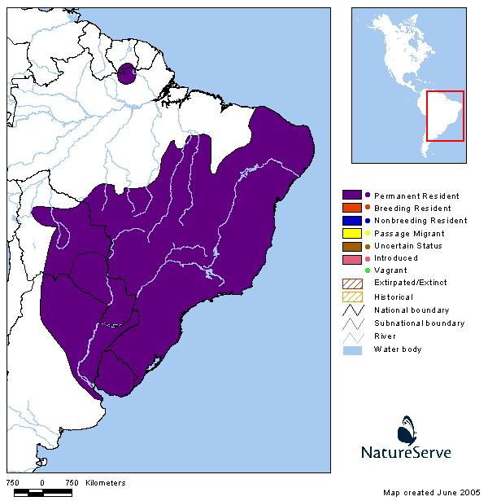
six banded or yellow armadillo

Domain: Eukarya
Kingdom Animalia
Phylum Chordata
Subphylum Vertebrata
Class Mammalia
Subclass Theria
Infraclass Eutheria
Clade Xenarthra
Superorder Xenarthra
Order Cingulata
Family Dasypus
Euphractus sexcinctus

Mass: 5 kg.
(11 lb.)

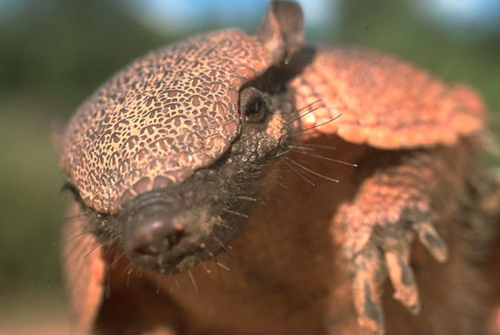

4047 Glossotherium chapadmalensis

Ground Sloth

Age: Pliocene
Found: Florida USA

Domain: Eukarya
Kingdom Animalia
Phylum Chordata
Subphylum Vertebrata
Class Mammalia
Subclass Theria
Infraclass Eutheria
Clade Xenarthra
Superorder Xenarthra
Order Pilosa
Family Mylodontidae
Glossotherium chapadmalensis

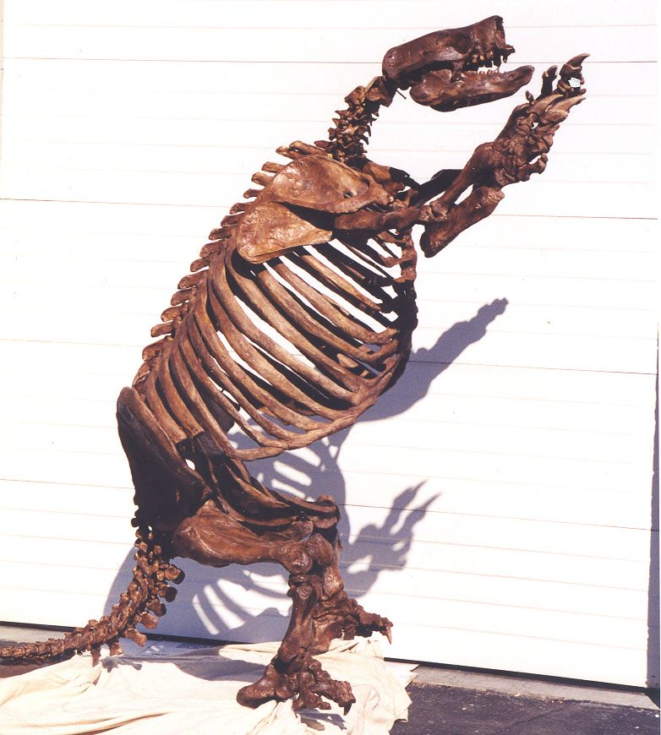

4048 Glyptodon calvipes
glyptodont

Age: Pleistocene
Found: Uruguay

Domain: Eukarya
Kingdom Animalia
Phylum Chordata
Subphylum Vertebrata
Class Mammalia
Subclass Theria
Infraclass Eutheria
Clade Xenarthra
Superorder Xenarthra
Order Cingulata
Family Glyptodontidae
Glyptodon calvipes

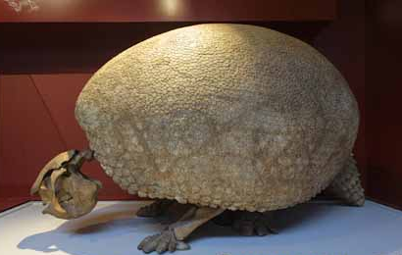

4049 Holmesina septentrionalis
pampathere

Age: Pleistocene
Found: Florida, USA

Domain: Eukarya
Kingdom Animalia
Phylum Chordata
Subphylum Vertebrata
Class Mammalia
Subclass Theria
Infraclass Eutheria
Clade Xenarthra
Superorder Xenarthra
Order Pilosa
Family Pampatheriidae
Holmesina septentrionalis

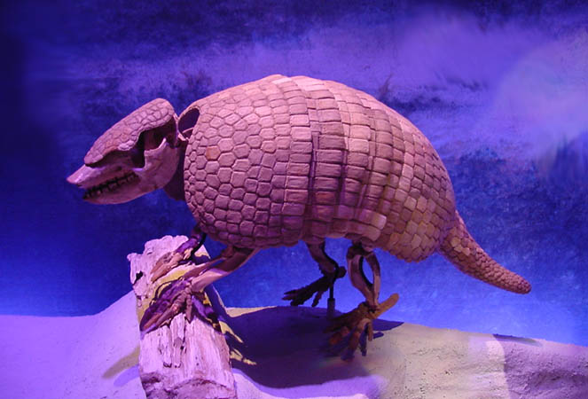

4050 Megalonyx jeffersoni
ground sloth

Age: Pleistocene
Found: Florida

Domain: Eukarya
Kingdom Animalia
Phylum Chordata
Subphylum Vertebrata
Class Mammalia
Subclass Theria
Infraclass Eutheria
Clade Xenarthra
Superorder Xenarthra
Order Pilosa
Family Megalonychidae
Megalonyx
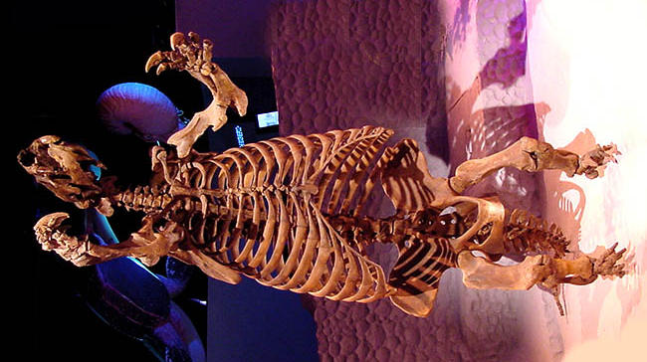
4060 Myrmecophaga tridactyla
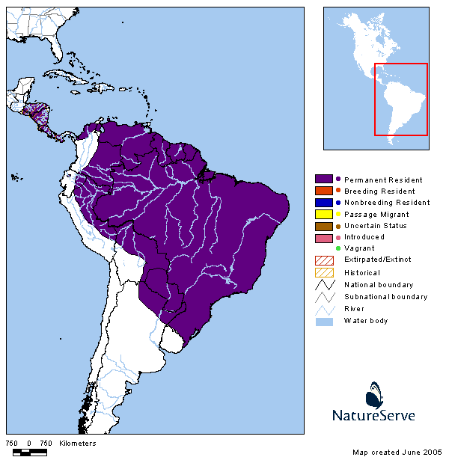
giant anteater

Domain: Eukarya
Kingdom Animalia
Phylum Chordata
Subphylum Vertebrata
Class Mammalia
Subclass Theria
Infraclass Eutheria
Clade Xenarthra
Superorder Xenarthra
Order Pilosa
Family Myrmecophagidae
Myrmecophaga tridactyla

Mass: 18-39 kg
(39-85 lb)

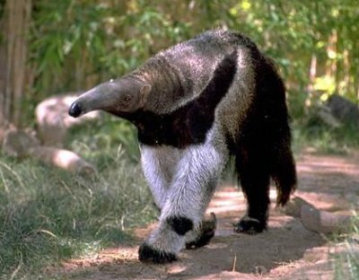

4061 Panochthus tuberculatus
Glyptodont

Age: Pleistocene 0.5 MYA
Found: Argentina Rio Lujan

Domain: Eukarya
Kingdom Animalia
Phylum Chordata
Subphylum Vertebrata
Class Mammalia
Subclass Theria
Infraclass Eutheria
Clade Xenarthra
Superorder Xenarthra
Order Pilosa
Family Glyptodontidae
Panochthus tuberculatus

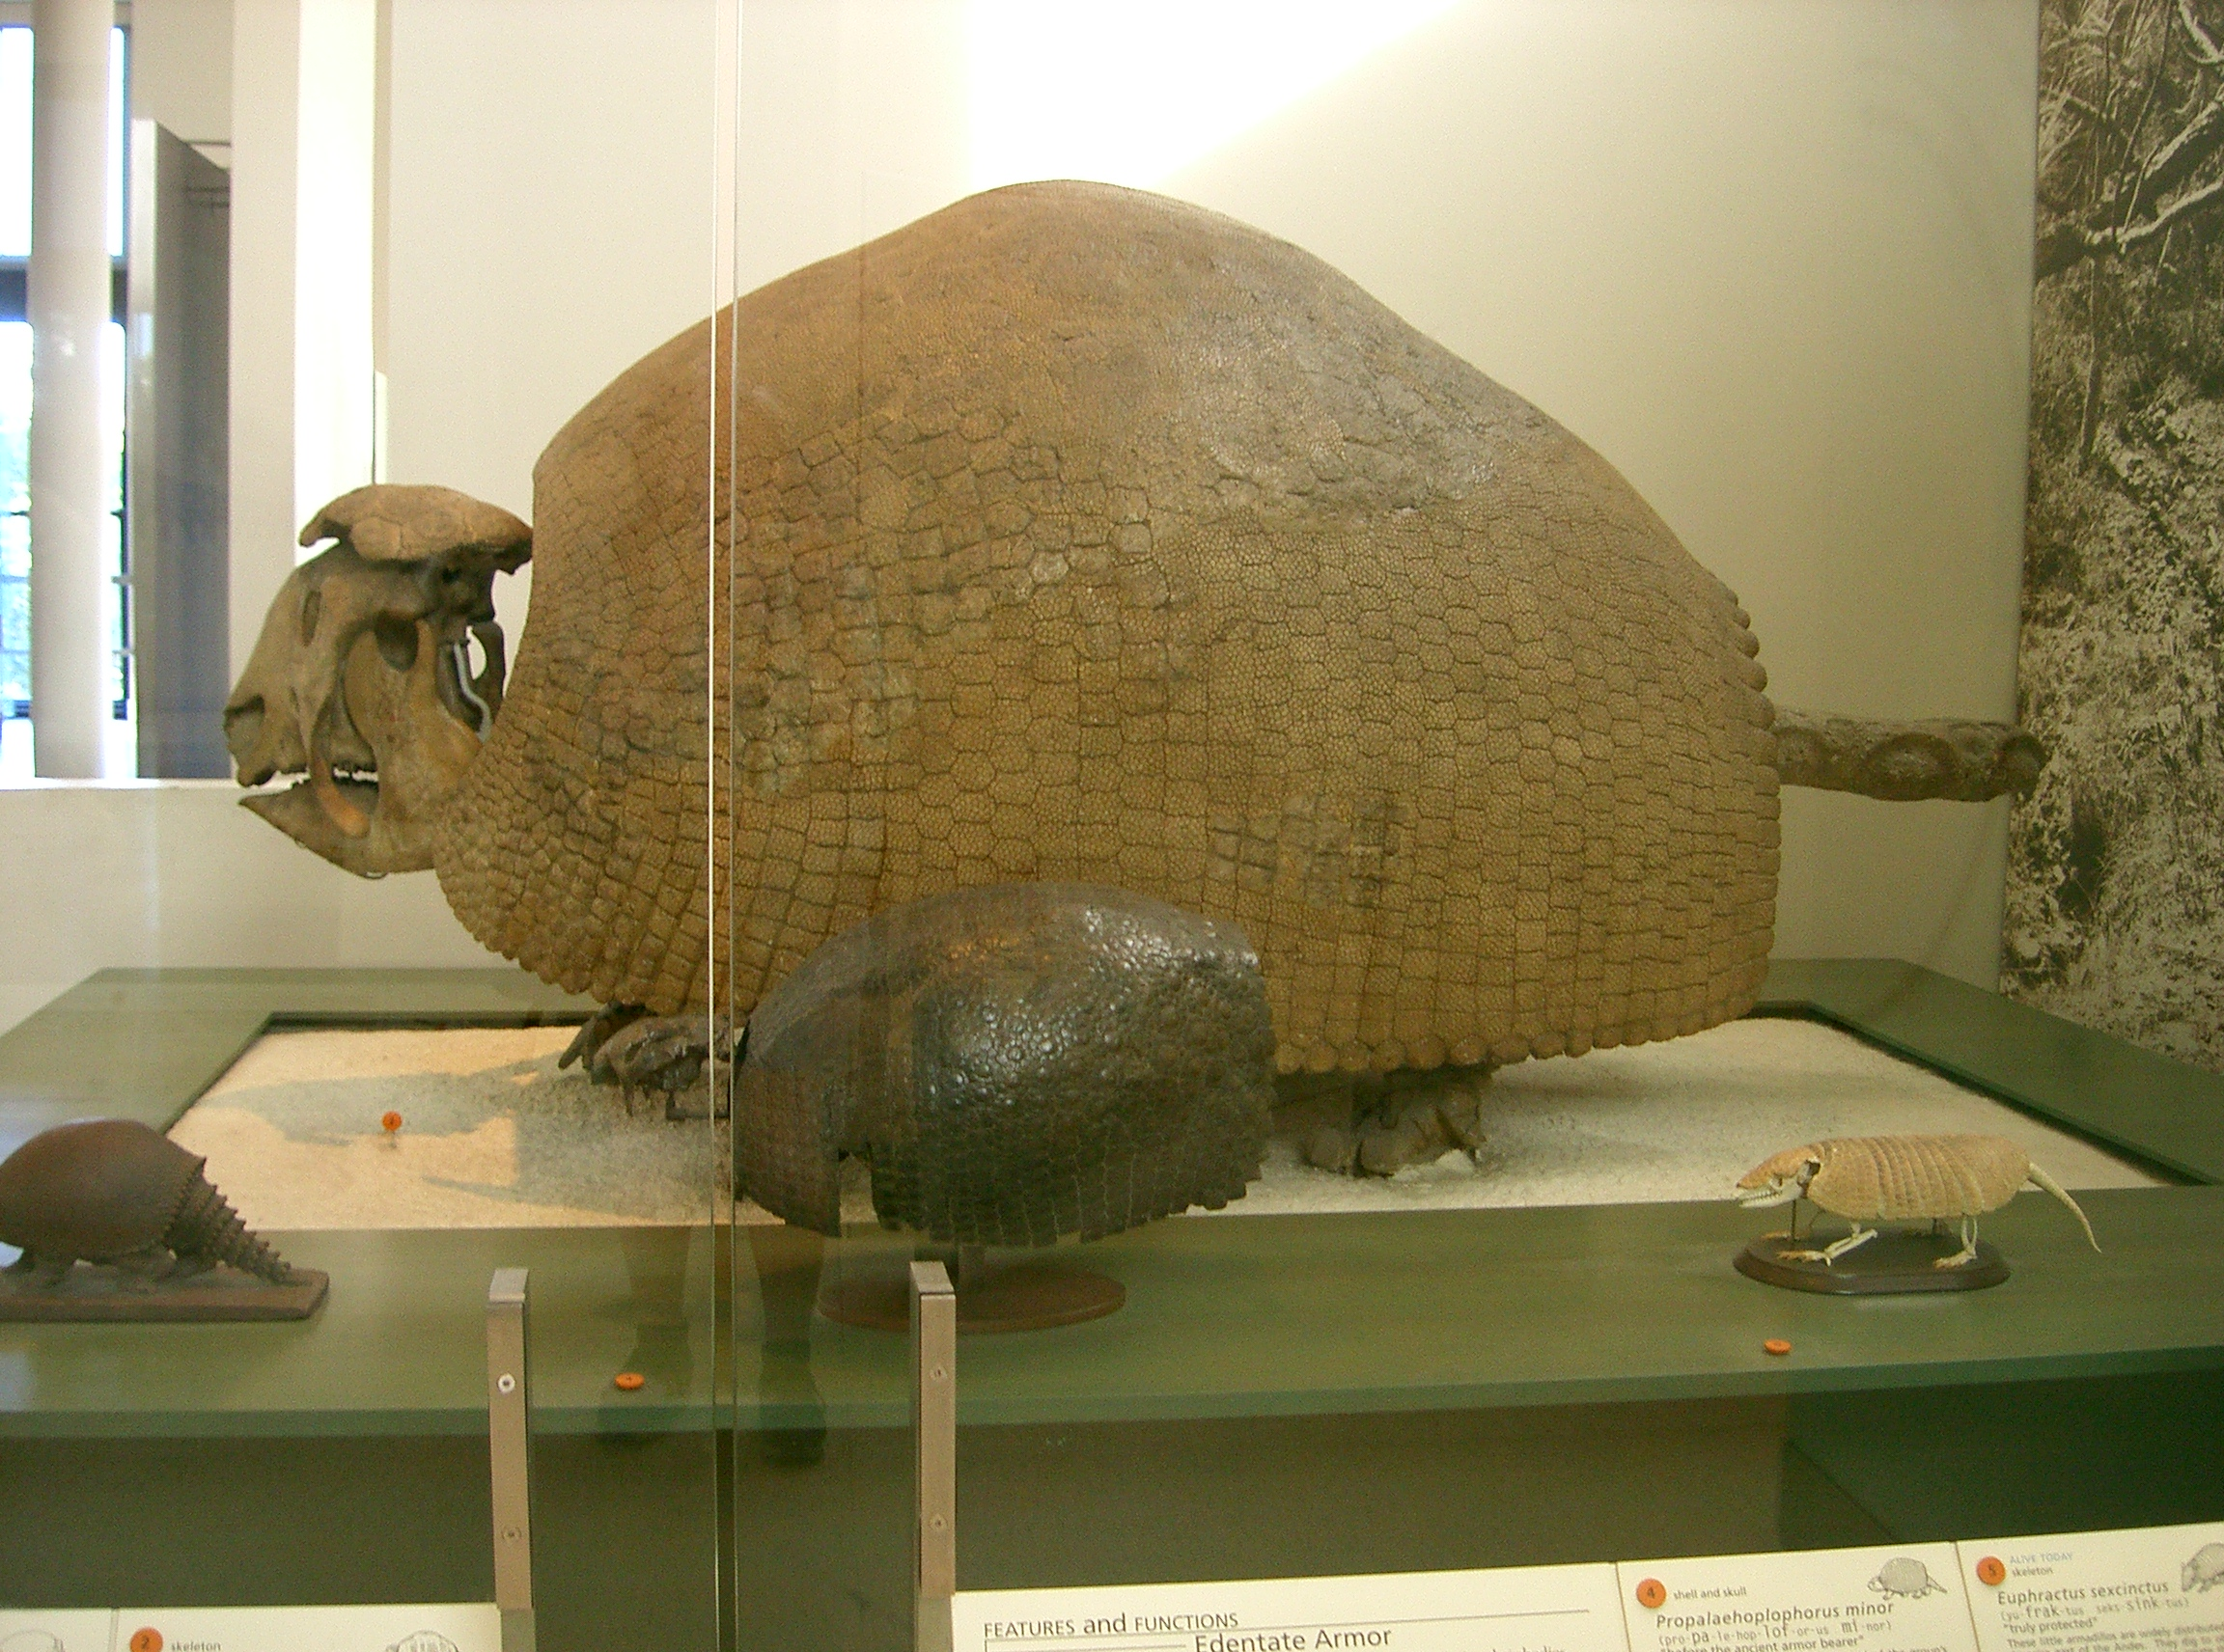

4062 Priodontes maximus
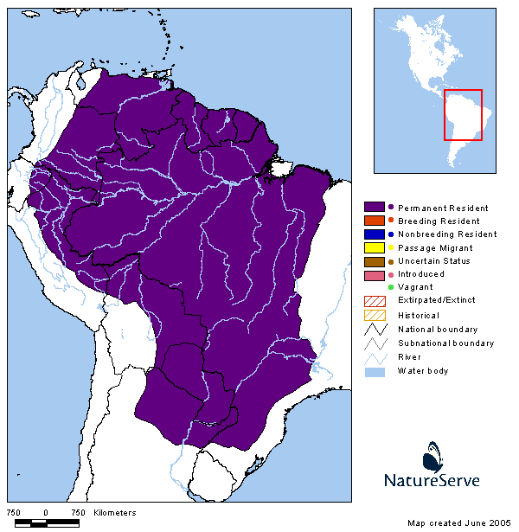
giant armadillo

Domain: Eukarya
Kingdom Animalia
Phylum Chordata
Subphylum Vertebrata
Class Mammalia
Subclass Theria
Infraclass Eutheria
Clade Xenarthra
Superorder Xenarthra
Order Pilosa
Family Dasypodidae
Priodontes maximus

Mass: 18.7-68.04 kg
(41-150 lb.)
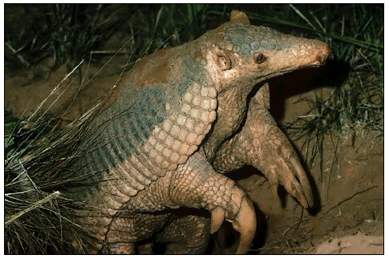

4063 Scelidodon sp.
ground sloth

Age: Pleistocene
Found: Argentina

Domain: Eukarya
Kingdom Animalia
Phylum Chordata
Subphylum Vertebrata
Class Mammalia
Subclass Theria
Infraclass Eutheria
Clade Xenarthra
Superorder Xenarthra
Order Pilosa
Family Mylodontidae
Scelidodon sp.
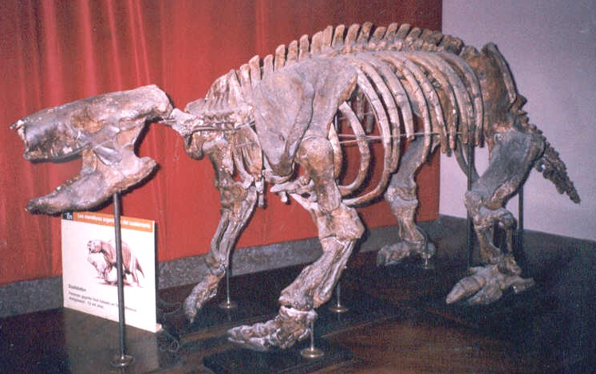

4059 Tamandua mexicana
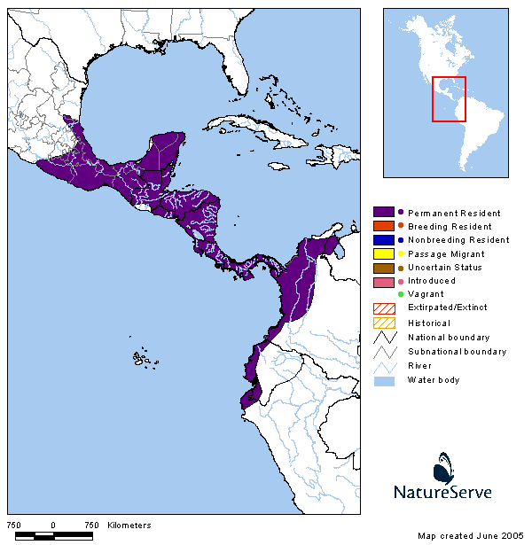
northern tamandua

Domain: Eukarya
Kingdom Animalia
Phylum Chordata
Subphylum Vertebrata
Class Mammalia
Subclass Theria
Infraclass Eutheria
Clade Xenarthra
Superorder Xenarthra
Order Pilosa
Family Myrmecophagidae
Tamandua mexicana

Mass: 2-7 kg
(4-15 lb.)

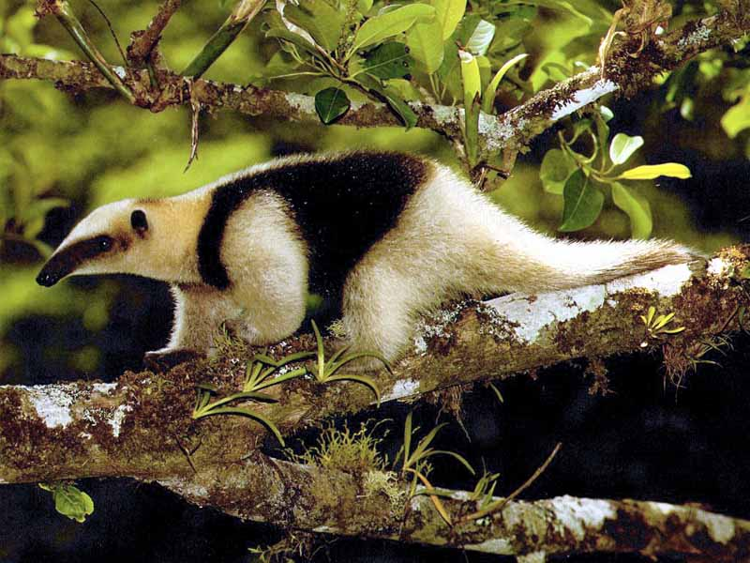

4051-4058 Miocene ground sloths
unidentified

Age: Miocene
Found: Argentina, Patagonia

Domain: Eukarya
Kingdom Animalia
Phylum Chordata
Subphylum Vertebrata
Class Mammalia
Subclass Theria
Infraclass Eutheria
Clade Xenarthra
Superorder Xenarthra
Order Pilosa
Family unidentified - probably Megalonychidae
ground sloth

Didelphis virginiana
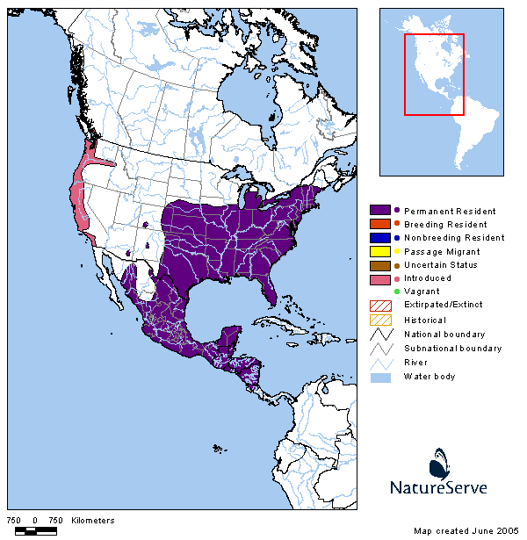
Virginia opossum
OUTGROUP

Domain: Eukarya
Kingdom Animalia
Phylum Chordata
Subphylum Vertebrata
Class Mammalia
Subclass Theria
Infraclass Metatheria
Order Didelphimorphia
Family Didelphidae
Didelphis virginiana

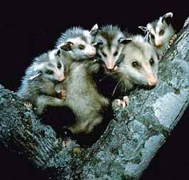
Mass: .3-6.4 kg
(.66-14 lb.)

Tachyglossus aculeatus

echnida or spiny anteater
OUTGROUP

Domain: Eukarya
Kingdom Animalia
Phylum Chordata
Subphylum Vertebrata
Class Mammalia
Subclass Prototheria
Order Monotremata
Family Tachyglossidae
Tachyglossus aculeatus
Mass: 2.5-6 kg
(5.5-13.2 lb.)

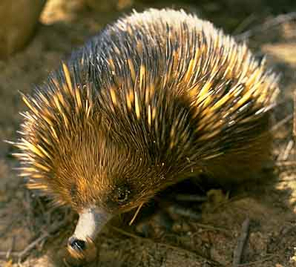

Calipers

Precision molded of high-impact plastic. Upper scale capacity is over 6" with reading accuracy of 1/128". Lower scale capacity is 155 mm with reading accuracy of 0.05 mm. Measures inside and outside dimensions.


Our big, strapping brushed-aluminum vernier caliper measures from 0-24" in 1/16" increments, and 0-61 cm in 1 mm increments. Also has 1/128" and .05 mm vernier scales, a knurled thumbscrew to lock in the measurement. Entire unit is 29-3/8" long with 3" deep jaws.



How to read a vernier caliper:

1. Read the out edge of the caliper jaw with the numbers on the scale on top. This is the number before the decimal. Note in this case, each tick mark on the upper scale is 0.1. The first reading is:
17.
Step 2
Step 1
17.
.34

2. Using the lower scale, find the line below that best matches up with the line above. Note in this case, each tick mark on the lower scale is 0.2. The second reading is:
.34

Therefore, the caliper measurement is: 17.34
Cenozoic Time

2—0.10 MYA Bolivia Catonyx tarijensis, Uruguay
Glyptodon calvipes, Florida Holmesina,
septentrionalis Argentina Panochthus,
5—2 MYA tuberculatus
Florida Glossotherium chapadmalensis
24—5 MYA Patagonia five unidentified ground sloths

34—24 MYA

55—34 MYA

65—55 MYA First fossil - armadillo form

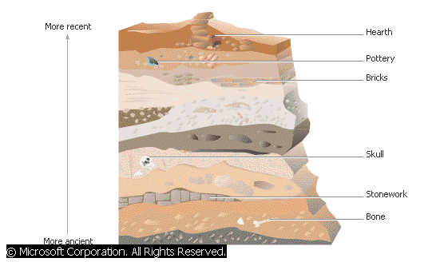

Phylogeny of Extant Xenarthra

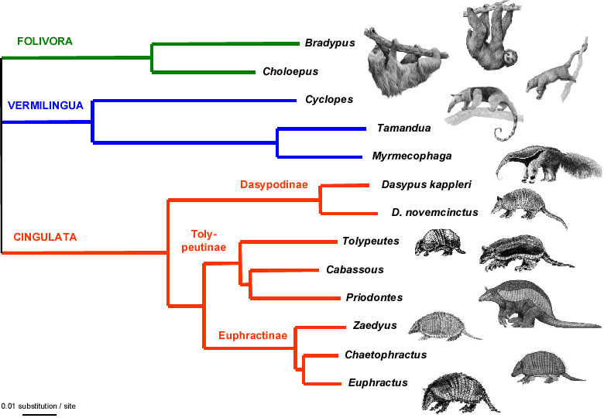

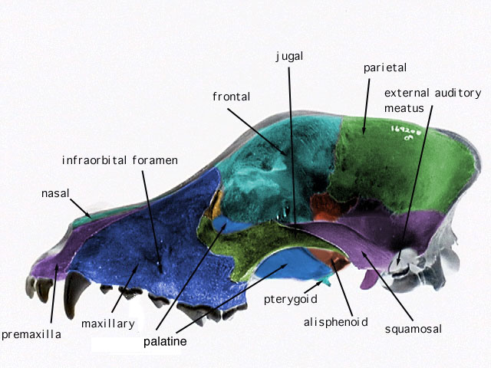
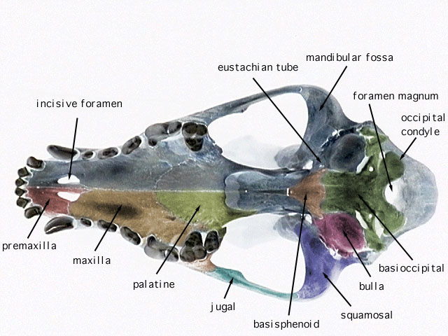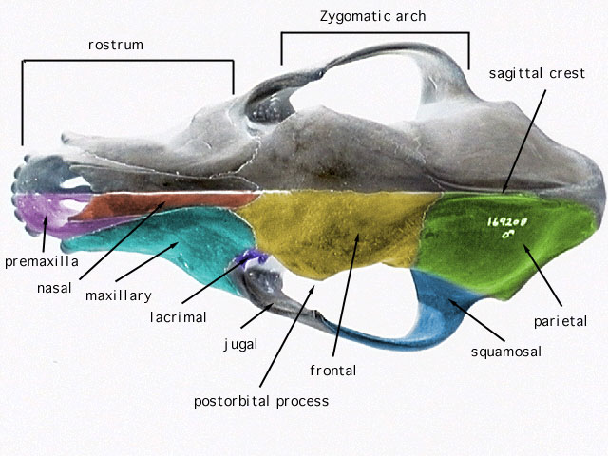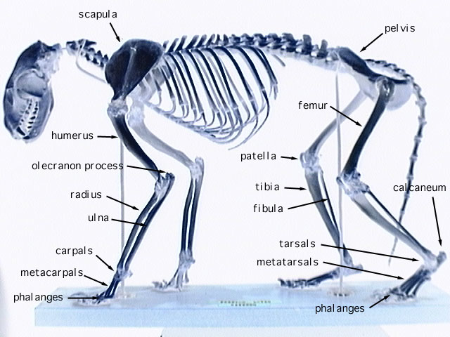
PSU # | Specimen | Common Name | Time | Place
4021 | Bradypus tridactylus | pale-throated three-toed sloth | Extant | SA
4022 | Cabassous uncinctus | southern naked-tailed armadillo | Extant | SA
4023 | Catonyx tarijensis | Mylodontid ground sloth | Pleistocene | Bolivia
4024 | Choloepus didactylus | Linné's two-toed sloth | Extant | SA
4025 | Choloepus hoffmanni | Hoffmann's two-toed sloth | Extant | CA SA
4026 | Dasypus novemcinctus | nine-banded armadillo | Extant | New World
4027 | Dasypus novemcinctus | nine-banded armadillo | Extant | New World
4028 | Dasypus novemcinctus | nine-banded armadillo | Extant | New World
4029 | Dasypus novemcinctus | nine-banded armadillo | Extant | New World
4030 | Dasypus novemcinctus | nine-banded armadillo | Extant | New World
4031 | Dasypus novemcinctus | nine-banded armadillo | Extant | New World
4032 | Dasypus novemcinctus | nine-banded armadillo | Extant | New World
4033 | Dasypus novemcinctus | nine-banded armadillo | Extant | New World
4034 | Dasypus novemcinctus | nine-banded armadillo | Extant | New World
4035 | Dasypus novemcinctus | nine-banded armadillo | Extant | New World
4036 | Dasypus novemcinctus | nine-banded armadillo | Extant | New World
4037 | Dasypus novemcinctus | nine-banded armadillo | Extant | New World
4038 | Dasypus novemcinctus | nine-banded armadillo | Extant | New World
4039 | Dasypus novemcinctus | nine-banded armadillo | Extant | New World
4040 | Dasypus novemcinctus | nine-banded armadillo | Extant | New World
4041 | Didelphis virginana | Virginia opossum | Extant | CA NA
4042 | Didelphis virginana | Virginia opossum | Extant | CA NA
4043 | Didelphis virginana | Virginia opossum | Extant | CA NA
4044 | Didelphis virginana | Virginia opossum | Extant | CA NA
4045 | Didelphis virginana | Virginia opossum | Extant | CA NA
4046 | Euphractus sexcinctus | six-banded armadillo | Extant | SA
4047 | Glossotherium chapadmalensis | Mylodontid ground sloth | Pliocene | Florida
4048 | Glyptodon calvipes | glyptodon | Pleistocene | Uruguay
4049 | Holmesina septentrionalis | extinct giant armadillo | Pleistocene | Florida
4050 | Megalonyx jeffersoni | Megalonychid ground sloth | Pleistocene | Florida
4051 | Miocene ground sloth | unidentified | Miocene | Argentina
4052 | Miocene ground sloth | unidentified | Miocene | Argentina
4053 | Miocene ground sloth | unidentified | Miocene | Argentina
4054 | Miocene ground sloth | unidentified | Miocene | Argentina
4055 | Miocene ground sloth | unidentified | Miocene | Argentina
4056 | Miocene ground sloth | unidentified | Miocene | Argentina
4057 | Miocene ground sloth | unidentified | Miocene | Argentina
4058 | Miocene ground sloth | unidentified | Miocene | Argentina
4059 | Tamandua mexicana | northern lesser anteater | Extant | CA SA
4060 | Myrmecophaga tridactyla | giant anteater | Extant | CA SA
4061 | Panochthus tuberculatus | glyptodon | Pleistocene | Argentina
4062 | Priodontes maximus | giant armadillo | Extant | SA
4063 | Scelidodon | Scelidotheriid ground sloth | Pleistocene | Argentina
4064 | Tachyglossus aculatus | echidna | Extant | Australia
4059 | Tamandua mexicana | northern lesser anteater | Extant | CA SA
Citations:
Pictures from the assessment tool and notebook; stories from the notebook:
- Cover
  - Chlamyphorus truncates – BJ Shaw – articulated skeleton in American Museum of Natural History, NYC
  - Choloepus sp. – http://www.museumofosteology.org/
  - All fossils – BJ Shaw – articulated skeleton in American Museum of Natural History, NYC
  - Tamandua tetradactyla – BJ Shaw – articulated skeleton in Portland State University Museum of Vertebrate Biology
- Bradypus tridactylus
http://www.hedweb.com/animimag/sloths.jpg
- Cabassous uncinctus
http://www.msu.edu/~nixonjos/armadillo/pics/c_unicinctus.jpg
- Calipers
  - vernier: https://www2.carolina.com/webapp/wcs/stores/servlet/ProductDisplay?jdeAddressId=&catalogId=10101&storeId=10151&productId=20528&langId=-1&parent_category_rn=&crumbs=n
  - giant: http://www.sciplus.com/singleItem.cfm?terms=9935&cartLogFrom=Search
  - closeup: http://www.longislandindicator.com/Resources/etalonvernier1a.jpeg
- Catonyx tarijensis
Barbara J. Shaw – articulated skeleton in American Museum of Natural History NYC
- Cenozoic Geologic Time
http://www.ucmp.berkeley.edu/cenozoic/cenostrat.html
- Choloepus didactylus
http://medicine.ucsd.edu/cpa/chol.html
- Choloepus hoffmanni
http://www.hoglezoo.org/animals/view.php?id=17
- Dasypus novemcinctus
http://www.floridanature.org/species.asp?species=Dasypus_novemcinctus
pelotes.jea.com/armad.htm
- Didelphis virginiana
http://www.luna-zoo.com/images/opossu3.jpg
- Euphractus sexcinctus
http://www.chaco-wildlife.org/images/mammal/euphractus_sexcinctus_gr.jpg
- Extant distribution maps
http://www.natureserve.org/
- Extant xenarthrans tree
Delsuc F, Catzeflis FM., Stanhope MJ, Douzery EJP (2001) The evolution of armadillos, anteaters and sloths depicted by nuclear and mitochondrial phylogenies; implications for the status of the enigmatic fossil Eurotamandua, Proc R Soc Lond B 268:1605–1615.
- Extinct and Echidna distribution maps
http://www.lokar.com/interior_pages/images/world-map.jpg
- Glossotherium chapadmalensis
http://www.skulls-skeletons.com/catalog/images/L103%20Glossotherium.jpg
- Glyptodon calvipes
http://www.timerock.com/timerock/library/images/glyptodon.gif
http://www.acapixus.dk/photography/images/Pano03b.jpg
- Holmesina septentrionalis
www.paleodirect.com
- Mapinguari
http://www.pibburns.com/cryptost/mapingua.htm
- Megalonyx jeffersoni
www.paleodirect.com/ Im3-001.htm
- Megatherium
http://www.game-bay.de/bilder_v2/zzz2016109_mittel.jpg
- Myrmecophaga tridactyla
http://www.geocities.com/RainForest/4076/index30.html
- Panochthus tuberculatus
Barbara J. Shaw – articulated skeleton in American Museum of Natural History NYC
- Paramylodon
http://www.katura-art.com/Images/P_Paleo/paleo4_harlani_w.jpg
- Priodontes maximus
http://www.pla.net.py/enlaces/cnelm/980617/armadi.jpg
- Scelidodon
http://www.interfosil.com/public/8_24.jpg
- Skeleton
http://animaldiversity.ummz.umich.edu/site/resources/anatomical_images/raccoon_skeleton.jpg/view.html
- Skulls
  - http://animaldiversity.ummz.umich.edu/site/resources/anatomical_images/dog_skull/dog_dorsal.jpg/view.html
  - http://animaldiversity.ummz.umich.edu/site/resources/anatomical_images/dog_skull/dog_ventral.jpg/view.html
  - http://animaldiversity.ummz.umich.edu/site/resources/anatomical_images/dog_skull/dog_lateral.jpg/view.html
- Stratigraphy and fossil dig site
Dodick J, Orion N (2003) Measuring Student Understanding of Geological Time. Journal of Research in Science Teaching 40(4) 415-442.
- Superposition
http://library.thinkquest.org/J00645/media/stratigraphy.jpg
- Tachyglossus aculeatus
http://www.savci.upol.cz/gal/_1/jezura.jpg
- Tamandua mexicana
http://www.terrambiente.org/fauna/Mammiferi/xenarthra/myrmecophagidae/

Also see:
Discover Magazine, September 1999 by Marguerite Holloway
Beasts in the Mist - David Oren searches for giant sloth in Brazilian rainforest

